https://learn.microsoft.com/en-us/training/paths/design-implement-microsoft-azure-networking-solutions-az-700/
Introduction to Azure Virtual Networks
Capabilities of Azure Virtual Networks
- Communication with the internet. All resources in a VNet can communicate outbound to the internet, by default. You can communicate inbound to a resource by assigning a public IP address or a public Load Balancer. You can also use public IP or public Load Balancer to manage your outbound connections.
- Communication between Azure resources. There are three key mechanisms through which Azure resource can communicate: VNets, VNet service endpoints, and VNet peering.
- Communication between on-premises resources. Securely extend your data center. You can connect your on-premises computers and networks to a virtual network using any of the following options: Point-to-site virtual private network (VPN), Site-to-site VPN, Azure ExpressRoute.
- Filtering network traffic. You can filter network traffic between subnets using any combination of network security groups and network virtual appliances.
- Routing network traffic. Azure routes traffic between subnets, connected virtual networks, on-premises networks, and the Internet, by default. You can implement route tables or border gateway protocol (BGP) routes to override the default routes Azure creates.
Design considerations for Azure Virtual Networks
Address space and subnets
You can create multiple virtual networks per region per subscription. You can create multiple subnets within each virtual network.
Virtual Networks
When you're creating a VNet, use address ranges enumerated in RFC 1918. These addresses are for private, nonroutable address spaces.
- 10.0.0.0 - 10.255.255.255 (10/8 prefix)
- 172.16.0.0 - 172.31.255.255 (172.16/12 prefix)
- 192.168.0.0 - 192.168.255.255 (192.168/16 prefix)
In addition, these address ranges are reserved.
- 224.0.0.0/4 (Multicast)
- 255.255.255.255/32 (Broadcast)
- 127.0.0.0/8 (Loopback)
- 169.254.0.0/16 (Link-local)
- 168.63.129.16/32 (Internal DNS)
Azure assigns resources in a virtual network a private IP address from the address space that you create. For example, if you deploy a VM in a VNet with subnet address space 192.168.1.0/24, the VM is assigned a private IP like 192.168.1.4. Azure reserves the first four and last IP address for a total of five IP addresses within each subnet. These addresses are x.x.x.0-x.x.x.3 and the last address of the subnet.
For example, the IP address range of 192.168.1.0/24 has the following reserved addresses:
- 192.168.1.0
- 192.168.1.1 (Reserved by Azure for the default gateway.)
- 192.168.1.2, 192.168.1.3 (Reserved by Azure to map the Azure DNS IPs to the VNet space.)
- 192.168.1.255 (Network broadcast address.)
Subnets
A subnet is a range of IP address in the VNet. You segment VNets into different size subnets. The smallest supported IPv4 subnet is /29, and the largest is /2 (using CIDR subnet definitions). IPv6 subnets must be exactly /64 in size. When planning to implement subnets, consider:
- Each subnet must have a unique address range, specified in Classless Inter-Domain Routing (CIDR) format.
- Certain Azure services require their own subnet.
- Subnets can be used for traffic management. For example, you can create subnets to route traffic through a network virtual appliance.
- You can limit access to Azure resources to specific subnets with a virtual network service endpoint. You can create multiple subnets, and enable a service endpoint for some subnets, but not others.
Considerations for virtual networks
When planning to implement virtual networks, you need to consider:
- Ensure nonoverlapping address spaces. Make sure your VNet address space (CIDR block) doesn't overlap with your organization's other network ranges.
- Is any security isolation required?
- Do you need to mitigate any IP addressing limitations?
- Are there connections between Azure VNets and on-premises networks?
- Is there any isolation required for administrative purposes?
- Are you using any Azure services that create their own VNets?
Configure public IP services
Public networks like the Internet communicate by using public IP addresses. Private networks like your Azure Virtual Network use private IP addresses
Public IP addresses enable Internet resources to communicate with Azure resources and enable Azure resources to communicate outbound with Internet and public-facing Azure services. A public IP address in Azure is dedicated to a specific resource. A resource without a public IP assigned can communicate outbound through network address translation services, where Azure dynamically assigns an available IP address that isn't dedicated to the resource.
Use dynamic and static public IP addresses
A dynamic public IP address is an assigned address that can change over the lifespan of the Azure resource. The IP address is released when you stop or delete the VM. The default allocation method is dynamic.
A static public IP address is an assigned address that doesn't change over the lifespan of the Azure resource. To ensure that the IP address for the resource remains the same, set the allocation method explicitly to static. The IP address is released only when you delete the resource or change the IP allocation method to dynamic.
Private DNS services
Private DNS services provides a reliable and secure DNS service for your virtual networks. Azure Private DNS manages and resolves domain names in the virtual network without the need to configure a custom DNS solution. By using private DNS zones, you can use your own custom domain name instead of the Azure-provided names during deployment.
Considerations
- Removes the need for creating custom DNS solutions.
- Hosts your custom DNS records, including hostname records.
- Provides hostname resolution between virtual networks.
- Private DNS zones can be shared between virtual networks. This capability simplifies cross-network and service-discovery scenarios, such as virtual network peering.
- The Azure DNS private zones feature is available in all Azure regions in the Azure public cloud.
Public DNS services
Azure public DNS is a hosting service for DNS domains that provides name resolution by using Microsoft Azure infrastructure.
- The name of the DNS zone must be unique within the resource group, and the zone must not exist already.
- The same zone name can be reused in a different resource group or a different Azure subscription.
- Where multiple zones share the same name, each instance is assigned different name server addresses.
- The root/parent zone is registered at the registrar and pointed to Azure NS name servers.
Azure Private DNS Zones
Private DNS zones in Azure are available for internal resources only. They're global in scope, so you can access them from any region, any subscription, any VNet, and any tenant. If you have permission to read the zone, you can use it for name resolution. Private DNS zones are highly resilient, being replicated to regions all throughout the world. They aren't available to resources on the internet.
Enable cross-virtual network connectivity with peering
Network traffic between peered virtual networks is private. The virtual networks appear as one for connectivity purposes. The traffic between virtual machines in peered virtual networks uses the Microsoft backbone infrastructure, and no public Internet, gateways, or encryption is required in the communication between the virtual networks.
- Regional VNet peering connects Azure virtual networks in the same region.
- Global VNet peering connects Azure virtual networks in different regions. The peered virtual networks can exist in any Azure public cloud region or China cloud regions, but not in Government cloud regions. You can only peer virtual networks in the same region in Azure Government cloud regions.
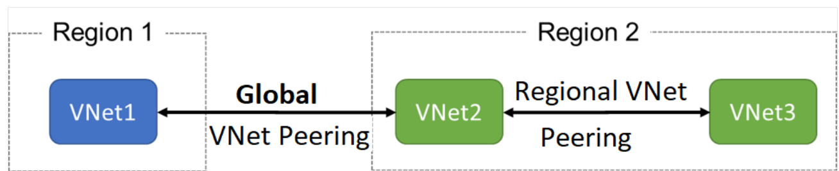
Benefits of virtual network peering
The benefits of using virtual network peering, whether local or global, include:
- A low-latency, high-bandwidth connection between resources in different virtual networks.
- The ability to apply network security groups in either virtual network to block access to other virtual networks or subnets.
- The ability to transfer data between virtual networks across Azure subscriptions, Microsoft Entra tenants, deployment models, and Azure regions.
- The ability to peer virtual networks created through the Azure Resource Manager.
- The ability to peer a virtual network created through Resource Manager to one created through the classic deployment model.
- No downtime to resources in either virtual network is required when creating the peering, or after the peering is created.
Gateway Transit and Connectivity
You can configure a VPN gateway in the peered virtual network as a gateway transit point. In this case, a peered virtual network uses the remote gateway to gain access to other resources. A virtual network can have only one gateway. Gateway transit is supported for both VNet Peering and Global VNet Peering.
Gateway Transit allows the virtual network to communicate to resources outside the peering. For example, the subnet gateway could:
- Use a site-to-site VPN to connect to an on-premises network.
- Use a VNet-to-VNet connection to another virtual network.
- Use a point-to-site VPN to connect to a client.

Implement virtual network traffic routing
Azure automatically creates a route table for each subnet within an Azure virtual network. The route table has the default system routes and any user defined routes you require. and adds system default routes to the table.
System routes
Azure automatically creates system routes and assigns the routes to each subnet in a virtual network. You can't create or remove system routes, but you can override some system routes with custom routes.
Source | Address prefixes | Next hop type
Default | Unique to the virtual network | Virtual network
Default | 0.0.0.0/0 | Internet
Default | 10.0.0.0/8 | None
Default | 192.168.0.0/16 | None
Default | 100.64.0.0/10 | None
Default system routes

In routing terms, a hop is a waypoint on the overall route. Therefore, the next hop is the next waypoint that the traffic is directed to on its journey to its ultimate destination. The next hop types are defined as follows:
- Virtual network: Routes traffic between address ranges within the address space of a virtual network. Azure creates a route with an address prefix that corresponds to each address range defined within the address space of a virtual network. Azure automatically routes traffic between subnets using the routes created for each address range.
- Internet: Routes traffic specified by the address prefix to the Internet. The system default route specifies the 0.0.0.0/0 address prefix. Azure routes traffic for any address not specified by an address range within a virtual network to the Internet, unless the destination address is for an Azure service. Azure routes any traffic destined for its service directly to the service over the backbone network, rather than routing the traffic to the Internet. You can override Azure's default system route for the 0.0.0.0/0 address prefix with a custom route.
- None: Traffic routed to the None next hop type is dropped, rather than routed outside the subnet.
Optional default system routes
Azure adds default system routes for any Azure capabilities that you enable. Depending on the capability, Azure adds optional default routes to either specific subnets within the virtual network, or to all subnets within a virtual network.
Expand table
Source | Address prefixes | Next hop type | Subnet within virtual network that route is added to
Default | Unique to the virtual network, for example: 10.1.0.0/16 | Virtual network peering | All
Virtual network gateway | Prefixes advertised from on-premises via BGP, or configured in the local network gateway. | All
Default | Multiple | VirtualNetworkServiceEndpoint | Only the subnet a service endpoint is enabled for.
- Virtual network (VNet) peering: When you create a virtual network peering between two virtual networks, a route is added for each address range within the address space of each virtual network.
- Virtual network gateway: When you add a virtual network gateway to a virtual network, Azure adds one or more routes with Virtual network gateway as the next hop type. The source is listed as virtual network gateway because the gateway adds the routes to the subnet.
- VirtualNetworkServiceEndpoint: Azure adds the public IP addresses for certain services to the route table when you enable a service endpoint to the service. Service endpoints are enabled for individual subnets within a virtual network, so the route is only added to the route table of a subnet a service endpoint is enabled for. The public IP addresses of Azure services change periodically, and Azure manages the updates to the routing tables when necessary.
User defined routes
You can override the default routes that Azure creates with user-defined routes (UDR). This technique can be useful when you want to ensure that traffic between two subnets passes through a firewall appliance. These custom routes override Azure's default system routes. In Azure, each subnet can have zero or one associated route table. When you create a route table and associate it to a subnet, the routes within it are combined with, or override, the default routes Azure adds to a subnet.
You can specify the following next hop types when creating a user-defined route:
- Virtual appliance: A virtual appliance is a virtual machine that typically runs a network application, such as a firewall. When you create a route with the virtual appliance hop type, you also specify a next hop IP address.
- Virtual network gateway: Specify when you want traffic destined for specific address prefixes routed to a virtual network gateway. The virtual network gateway must be created with type VPN.
- None: Specify when you want to drop traffic to an address prefix, rather than forwarding the traffic to a destination.
- Virtual network: Specify when you want to override the default routing within a virtual network.
- Internet: Specify when you want to explicitly route traffic destined to an address prefix to the Internet.

Consider Azure Route Server
Azure Route Serversimplifies dynamic routing between your network virtual appliance (NVA) and your virtual network. Azure Route Server is a fully managed service and is configured with high availability.
- You no longer need to manually update the routing table on your NVA whenever your virtual network addresses are updated.
- You no longer need to update user defined routes manually whenever your NVA announces new routes or withdraws old ones.
- You can peer multiple instances of your NVA with Azure Route Server.
- The interface between NVA and Azure Route Server is based on a common standard protocol. As long as your NVA supports BGP, you can peer it with Azure Route Server.
- You can deploy Azure Route Server in any of your new or existing virtual network.
Configure internet access with Azure Virtual NAT
Globally, IPv4 1ecan be an expensive way to grant access to Internet resources. Azure Network Address Translation (NAT) lets internal resources on a private network to share routable IPv4 addresses. Rather than purchasing an IPv4 address for each resource that requires internet access, you can use a NAT service to map outgoing requests from internal resources to an external IP address.
The following diagram shows outbound traffic flow from Subnet 1 through the NAT gateway to be mapped to a Public IP address or a Public IP prefix.
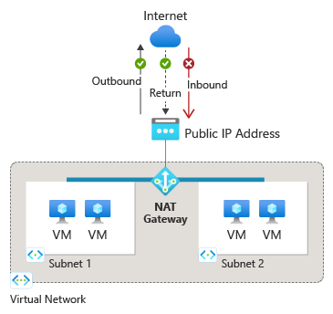
After NAT is configured, all UDP and TCP outbound flows from any virtual machine instance will use NAT for internet connectivity. No further configuration is necessary, and you don’t need to create any user-defined routes. NAT takes precedence over other outbound scenarios and replaces the default Internet destination of a subnet.
NAT scales automatically to support dynamic workloads. NAT can support up to 16 public IP addresses. By using port network address translation (PNAT or PAT), NAT provides up to 64,000 concurrent flows for UDP and TCP. NAT is compatible with the following standard SKU resources:
- Load balancer
- Public IP address
- Public IP prefix
Limitations of NAT
- Basic resources (for example basic load balancer) and any products derived from them aren't compatible with NAT. Basic resources must be placed on a subnet not configured with NAT.
- Only the IPv4 address family is supported. NAT doesn't interact with IPv6 address family.
- NAT can't span multiple virtual networks.
- IP fragmentation isn't supported.
The main takeaways from this module are:
- Azure virtual networks enable resources in Azure to securely communicate with each other, the internet, and on-premises networks.
- A subnet is a range of IP address in a virtual network. Each subnet must have a unique address range.
- Public networks like the Internet communicate by using public IP addresses. Private networks like your Azure Virtual Network use private IP addresses.
- A dynamic public IP address can change over the lifespan of the Azure resource. A static public IP address doesn't change over the lifespan of the Azure resource.
- Azure provides both public and private DNS resolution.
- Virtual network peering enables you to seamlessly connect two Azure virtual networks. Peering can be either global or regional.
- Azure automatically creates system routes and assigns the routes to each subnet in a virtual network. Each route contains an address prefix and next hop type.
- You can create custom, or user-defined(static), routes. To troubleshoot routing issues, you can view the effective routes for each network interface.
- NAT enables you to share a single public IPv4 address among multiple internal resources.

Design and implement hybrid networking
https://learn.microsoft.com/en-us/training/modules/design-implement-hybrid-networking/2-design-implement-vpn-gateway
Azure VPN Gateway is a service that can be used to send encrypted traffic between an Azure virtual network and on-premises locations over the public Internet.
Factors that you need to consider during your planning process include:
- Throughput - Mbps or Gbps
- Backbone - Internet or private?
- Availability of a public (static) IP address
- VPN device compatibility
- Multiple client connections or a site-to-site link?
- VPN gateway type
- VPN Gateway SKU
VPN Gateway SKUs
When you create a VPN Gateway, you must select the gateway SKU. You can select a SKU that satisfies your requirements based on the workload, throughput, feature, and SLAs.
VPN Gateway types
When you create the virtual network gateway, you must specify a VPN type. There are two VPN gateway types: policy-based and route-based
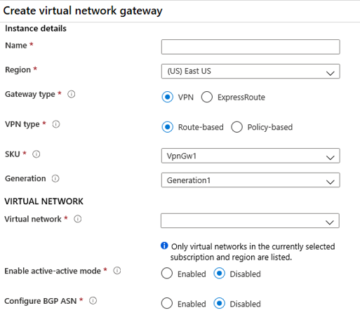
Policy-based gateways
Policy-based VPNs were previously called static routing gateways. Policy-based VPNs encrypt and direct packets through IPsec tunnels based on the IPsec policies.
limitations:
- Policy-based VPNs which support IKEv1 protocols can only be used with Basic Gateway SKUs.
- You can have only one tunnel when using a policy-based VPN.
- You can only use policy-based VPNs for site-to-site connections.
Route-based gateways
Route-based VPNs were previously called dynamic routing gateways. Route-based VPNs use "routes" in the IP forwarding or routing table to direct packets into their corresponding tunnel interfaces.
High availability options for VPN connections
To provide better availability for your VPN connections, consider one of these options.
- VPN Gateway redundancy (active-standby)
- Active-active Azure VPN gateway
Active-standby Azure VPN gateways
You can create an Azure VPN gateway in an active-standby configuration. Active-standby is the default configuration. In this configuration there are two instances, active and standby. The standby connection takes over when the active connection is disrupted. Switching to the standby connection causes a service disruption.
- For planned maintenance, connectivity is restored in seconds.
- For unplanned interruptions, connectivity is restored in minutes.
- For P2S client connections, they need to reconnect.
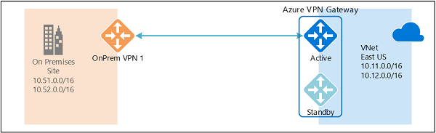
Active-active Azure VPN gateways
You can create an Azure VPN gateway in an active-active configuration. In the active-active configuration, both instances of the gateway establish VPN tunnels to your on-premises VPN device. The traffic from your Azure virtual network to your on-premises network is routed through both tunnels simultaneously. If an outage occurs, Azure automatically switches to the other tunnel.
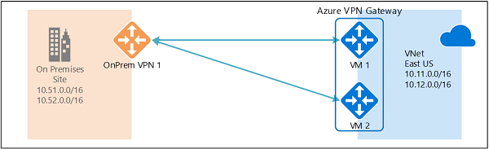
Architecture diagram
Important: Look closely at this design. Did you notice the CoreServicesSubnet overlaps with the GatewaySubnet? As a best practice, these subnets should be segregated to avoid potential connectivity issues.
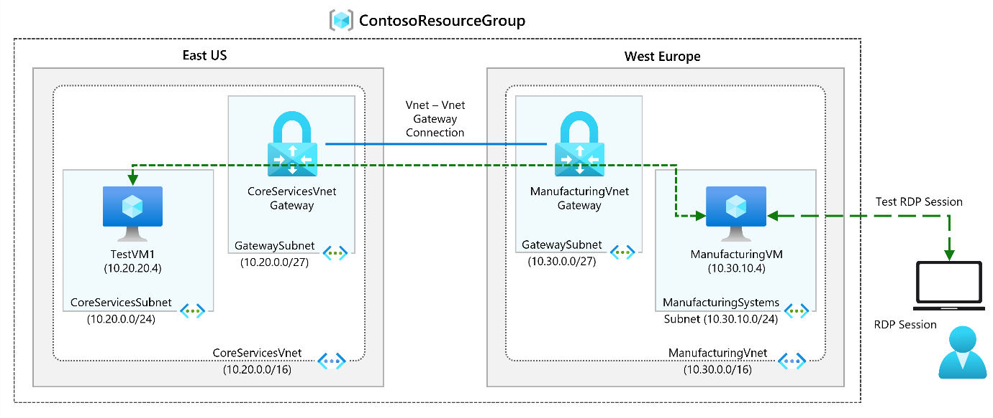
Objectives
- Task 1: Create CoreServicesVnet and ManufacturingVnet
  - Use a template to create the virtual networks. You can review the lab template.
  - Use Azure PowerShell to deploy the template.
- Task 2: Create CoreServicesTestVM
  - Use a template to create the virtual machines. You can review the lab template.
  - Use Azure PowerShell to deploy the template.
- Task 3: Create ManufacturingTestVM
  - Use a template to create the virtual machines. You can review the lab template.
  - Use Azure PowerShell to deploy the template.
- Task 4: Connect to the Test VMs using RDP
- Task 5: Test the connection between the VMs
- Task 6: Create CoreServicesVnet Gateway
- Task 7: Create ManufacturingVnet Gateway
- Task 8: CoreServicesVnet to ManufacturingVnet
- Task 9: Connect ManufacturingVnet to CoreServicesVnet
- Task 10: Verify that the connections connect
- Task 11: Test the connection between the VMs

Connect networks with Site-to-site VPN connections
A site-to-site (S2S) VPN gateway lets you create a secure connection to your virtual network from another virtual network or a physical network.
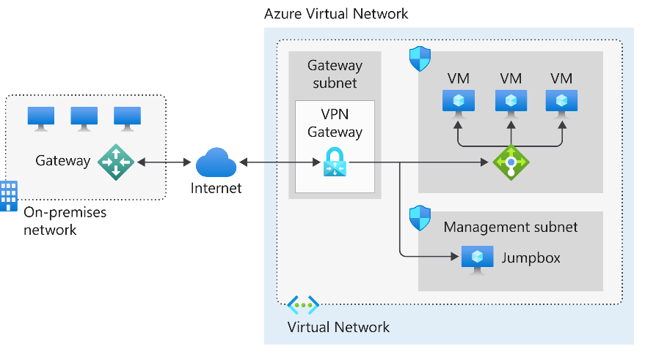
In the diagram:
- The on-premises network represents your on-premises Active Directory and any data or resources.
- The gateway is responsible for sending encrypted traffic to a virtual IP address when it uses a public connection.
- The Azure virtual network holds all your cloud applications and any Azure VPN gateway components.
- An Azure VPN gateway provides the encrypted link between the Azure virtual network and your on-premises network. An Azure VPN gateway is made up of these elements:
  - Virtual network gateway
  - Local network gateway
  - Connection
  - Gateway subnet
- An internal load balancer, located in the front end, routes cloud traffic to the correct cloud-based application or resource.
Using this architecture offers several benefits, including:
- Simplifying configuration and maintenance.
- Encrypting data and traffic between the on-premises gateway and the Azure gateway.
- Allowing for future network requirements.
Connect devices to networks with Point-to-site VPN connections
A Point-to-Site (P2S) VPN gateway connection lets you create a secure connection to your virtual network from an individual client computer.
VNet.
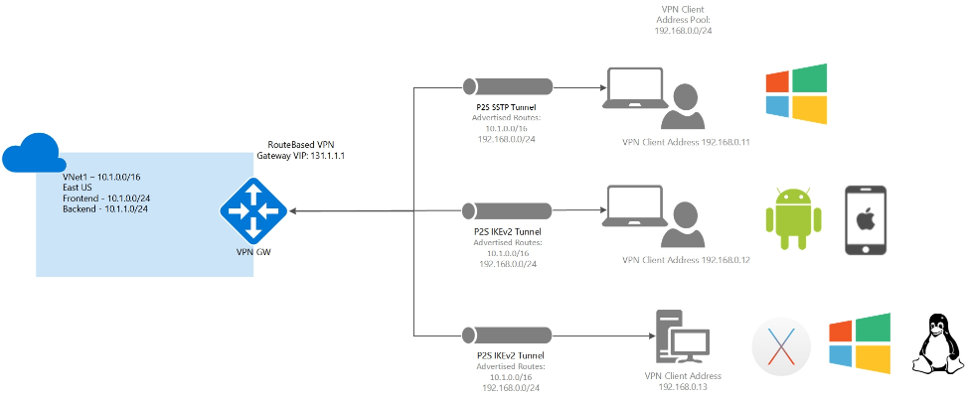
Point-to-site protocols
Point-to-site VPN can use one of the following protocols:
- OpenVPN® Protocol, an SSL/TLS based VPN protocol. A TLS VPN solution can penetrate firewalls, since most firewalls open TCP port 443 outbound, which TLS uses. OpenVPN can be used to connect from Android, iOS (versions 11.0 and above), Windows, Linux, and Mac devices (macOS versions 10.13 and above).
- Secure Socket Tunneling Protocol (SSTP), a proprietary TLS-based VPN protocol. A TLS VPN solution can penetrate firewalls, since most firewalls open TCP port 443 outbound, which TLS uses. SSTP is only supported on Windows devices. Azure supports all versions of Windows that have SSTP (Windows 7 and later).
- IKEv2 VPN, a standards-based IPsec VPN solution. IKEv2 VPN can be used to connect from Mac devices (macOS versions 10.11 and above).
Point-to-site authentication methods
- Authenticate using native Microsoft Entra ID authentication
Native authentication allows users to connect to Azure using their Microsoft Entra ID credentials. Native authentication is only supported for OpenVPN protocol and Windows and requires the use of the Azure VPN Client. With this authentication, you can use conditional access and multifactor authentication (MFA) features for VPN.
- Authenticate using Active Directory Domain Services
It requires a RADIUS server that integrates with the server.
The RADIUS server is deployed either on-premises or in your Azure VNet. During authentication, the Azure VPN Gateway passes authentication messages back and forth between the RADIUS server and the connecting device. Thus, the Gateway must be able to communicate with the RADIUS server. If the RADIUS server is present on-premises, then a VPN S2S connection from Azure to the on-premises site is required for reachability.

Connect remote resources by using Azure Virtual WANs
Azure Virtual WAN is a networking service that brings many networking, security, and routing functionalities together to provide a single operational interface. Some of the main features include:
- Branch connectivity (via connectivity automation from Virtual WAN Partner devices such as SD-WAN or VPN CPE).
- Site-to-site VPN connectivity.
- Remote user VPN connectivity (point-to-site).
- Private connectivity (ExpressRoute).
- Intra-cloud connectivity (transitive connectivity for virtual networks).
- VPN ExpressRoute inter-connectivity.
- Routing, Azure Firewall, and encryption for private connectivity.
This diagram shows an organization with two Virtual WAN hubs connecting the spokes. VNets, Site-to-site and point-to-site VPNs, SD WANs, and ExpressRoute connectivity are all supported.
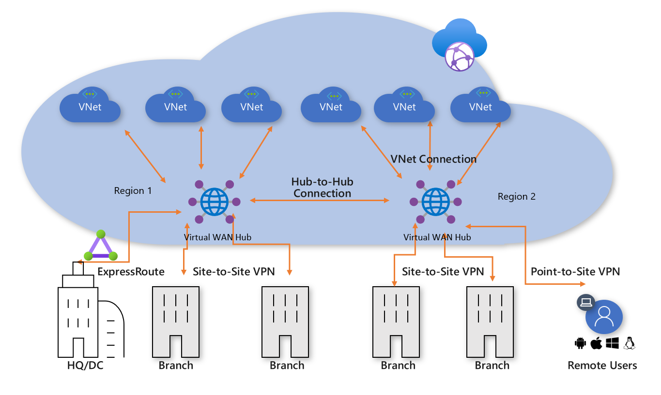
To configure an end-to-end virtual WAN, you create:
- Virtual WAN. This resource represents a virtual overlay of your Azure network and is a collection of multiple resources. It contains links to all your virtual hubs that you would like to have within the virtual WAN. Virtual WANs are isolated from each other and can't contain a common hub.
- Hub. A virtual hub is a Microsoft-managed virtual network. The hub contains various service endpoints to enable connectivity.
- Hub virtual network connection. The hub virtual network connection resource is used to connect the hub seamlessly to your virtual network. One virtual network can be connected to only one virtual hub.
- Hub-to-hub connection. Hubs are all connected to each other in a virtual WAN.
- Hub route table. You can create a virtual hub route and apply the route to the virtual hub route table. You can apply multiple routes to the virtual hub route table.
- Site (optional). This resource is used for site-to-site connections only.
Virtual WAN type | Hub type | Available configurations
Basic | Basic | Site-to-site VPN only
Standard | Standard | ExpressRoute  User VPN (P2S)  VPN (site-to-site)  Inter-hub and VNet-to-VNet transiting through the virtual hub  Azure Firewall  NVA in a virtual WAN

Architecture diagram
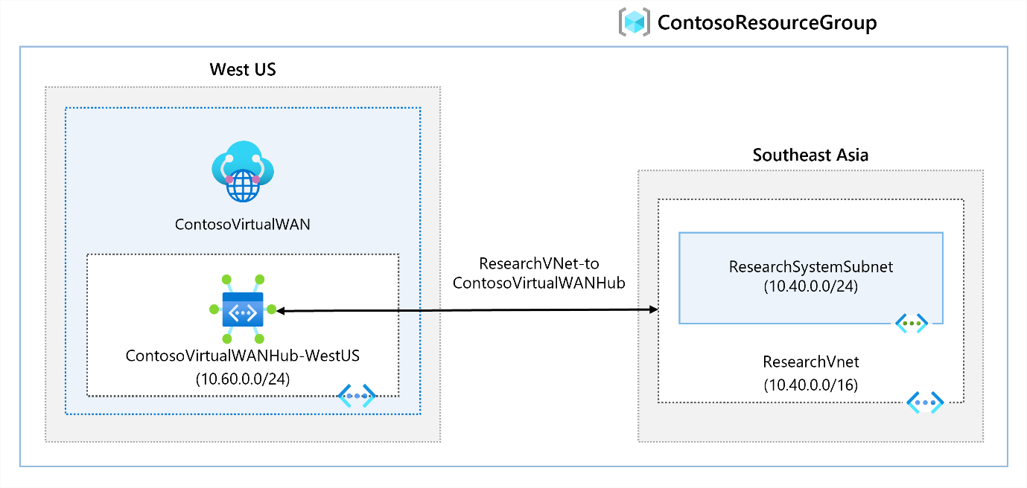
Objectives
- Task 1: Create a Virtual WAN.
- Task 2: Create a hub by using Azure portal.
- Task 3: Connect a VNet to the Virtual Hub.
Create a network virtual appliance (NVA) in a virtual hub
Azure Virtual WAN is the ability to support reliable connections from many different technologies. These technologies include ExpressRoute, VPN Gateway, Barracuda CloudGen WAN, Cisco Cloud OnRamp for multicloud, and VMware SD-WAN. These types of devices are known as network virtual appliances (NVAs). NVAs enable transitive connectivity throughout an organization's Virtual WAN.

Design and implement Azure ExpressRoute
https://learn.microsoft.com/en-us/training/modules/design-implement-azure-expressroute/
ExpressRoute lets you extend your on-premises networks into the Microsoft cloud over a private connection with the help of a connectivity provider.
ExpressRoute connections don't travel over the public Internet, this approach offers more reliability, faster speeds, consistent latencies, and higher security.
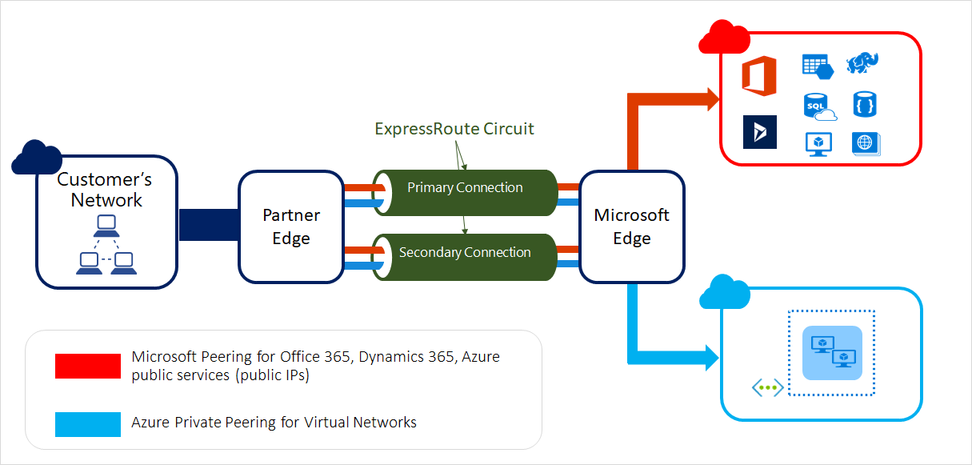
ExpressRoute connectivity models
ExpressRoute allows you to create a connection in two ways: the Service Provider model and the ExpressRoute Direct model. Within the Service Provider model there are three paths: CloudExchange Colocation, Point-to-point Ethernet Connection, and Any-to-any (IPVPN) Connection.
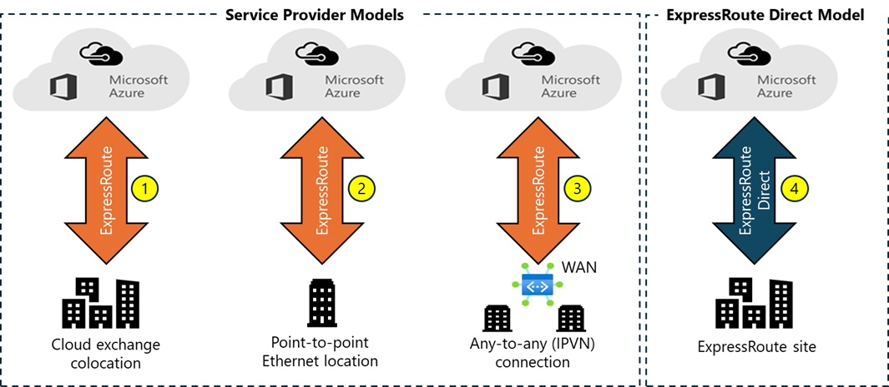
- Co-located at a cloud exchange. If you're colocated in a facility with a cloud exchange, you can request for virtual cross-connections to the Microsoft cloud through the colocation provider’s Ethernet exchange. Colocation providers can offer either Layer 2 cross-connections, or managed Layer 3 cross-connections between your infrastructure in the colocation facility and the Microsoft cloud.
- Point-to-point Ethernet connections. You can connect your on-premises datacenters or offices to the Microsoft cloud through point-to-point Ethernet links. Point-to-point Ethernet providers can offer Layer 2 connections.
- Any-to-any (IPVPN) networks. You can integrate your WAN with the Microsoft cloud. IPVPN providers (typically MPLS VPN) offer any-to-any connectivity between your branch offices and datacenters. The Microsoft cloud can be interconnected to your WAN to make it appear like any other branch office. WAN providers typically offer managed Layer 3 connectivity.
- ExpressRoute Direct. You can connect directly into the Microsoft global network at a peering location strategically distributed across the world. ExpressRoute Direct provides dual 100-Gbps or 10-Gbps connectivity that supports Active/Active connectivity at scale.
Feature/Aspect | ExpressRoute using a Service Provider | ExpressRoute Direct
Usage cases | Small to medium sized business looking for a simple setup with managed services | Large enterprises with mission-critical applications requiring high-performance connectivity
Connectivity | Connection via a service provider's infrastructure | Direct connection to Microsoft's network through dual 10-Gbps or 100-Gbps ports
Circuit SKUs | Ranges from 50 Mbps to 10 Gbps | 10-Gbps: 1, 2, 5, 10 Gbps; 100-Gbps: 5, 10, 40, 100 Gbps
Optimization | Optimized for single tenant with multiple business units | Optimized for a single tenant

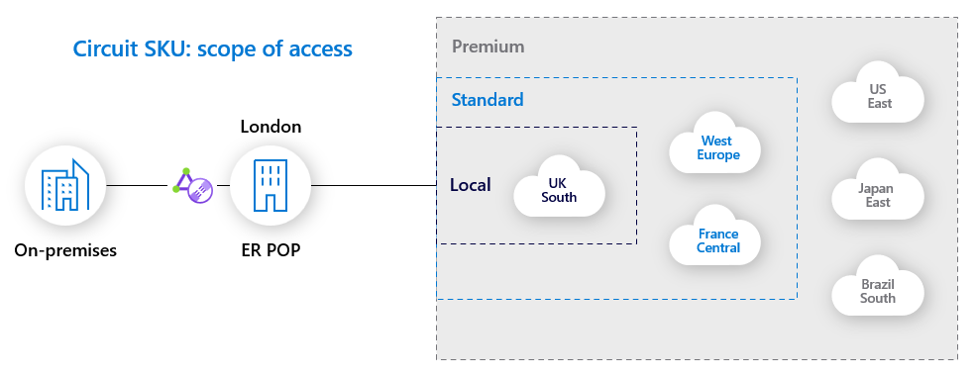
- Local SKU (if available). The Local SKU provides connectivity to a single Azure region. It's suitable for scenarios where you need low-latency access to resources in a particular Azure region.
- Standard SKU: The Standard SKU allows connectivity to multiple Azure regions within the same geopolitical area. The Standard SKU is useful for businesses that operate within a specific region but need access to resources across multiple locations.
- Premium SKU: The Premium SKU extends connectivity to all Azure regions globally. This SKU is ideal for multinational organizations that require seamless connectivity to Azure resources across different continents.
Configure peering for an ExpressRoute deployment
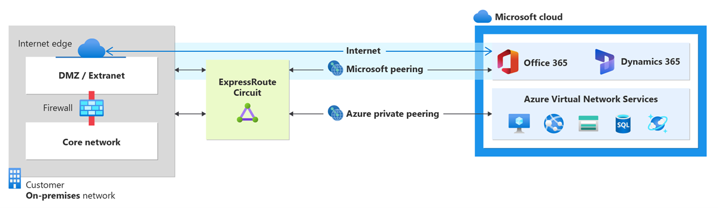
- Private peering. Private Peering is ideal for scenarios where you need secure, high-performance connectivity to Azure resources. Private peering allows you to connect on premises hosts with Azure IaaS and PaaS services configured to work with Azure virtual networks. All resources must be located in Azure virtual networks and allocated IP addresses in a private address space that doesn't overlap with your on-premises address space. You can’t connect to an Azure resource’s public IP address, such as an IaaS VM’s public IP address through private peering.
- Microsoft peering. Microsoft Peering is suitable for accessing Microsoft SaaS and PaaS services. Microsoft peering allows you to connect over ExpressRoute with Azure PaaS services, Microsoft 365 services, and Dynamics 365.
Feature | ExpressRoute Private Peering | ExpressRoute Microsoft Peering
Purpose | Connects directly to Azure virtual networks | Connects to Microsoft services like Office 365, Dynamics 365, and Azure PaaS services
Traffic Type | Private IP traffic | Public IP traffic
Access | Direct access to Azure VMs and services within virtual networks | Access to Microsoft SaaS services and Azure PaaS services
Security | Traffic stays on private network, not exposed to the internet | Traffic is routed over public IPs but through a private connection
Use Cases | Enterprise applications, databases, and other workloads requiring secure, high-performance connectivity | Access to Microsoft services like Office 365, Dynamics 365, and Azure PaaS services
Network Isolation | Provides network isolation from the public internet | Doesn't provide network isolation from the public internet, but ensures traffic doesn't traverse the public internet
Bandwidth Options | Offers scalable bandwidth options | Offers scalable bandwidth options

Improve data path performance between networks with ExpressRoute FastPath
ExpressRoute virtual network gateway facilitates the exchange of network routes and directs network traffic. ExpressRoute FastPath enhances data path performance between your on-premises network and your virtual networks. When enabled, ExpressRoute FastPath routes network traffic directly to virtual machines, bypassing the ExpressRoute virtual network gateway.
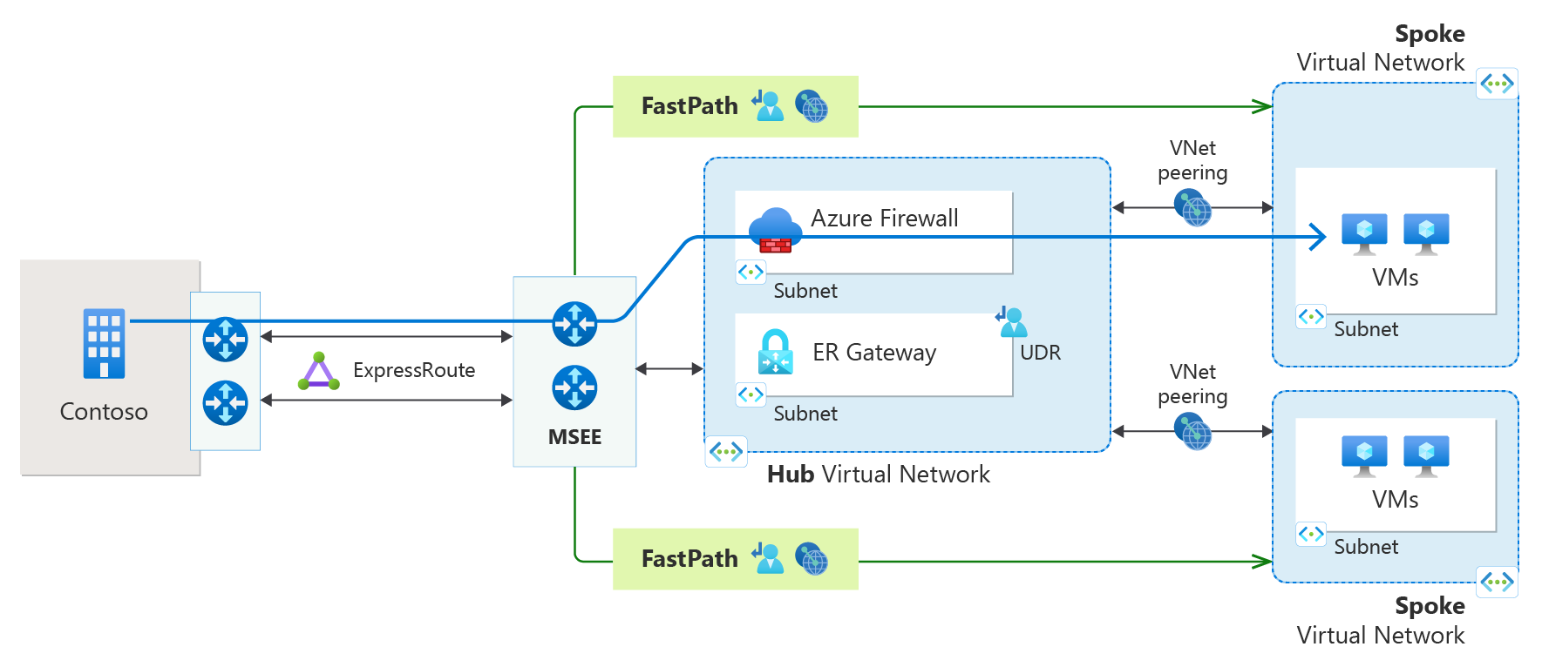
Load balance non-HTTP(S) traffic in Azure
https://learn.microsoft.com/en-us/training/modules/load-balancing-non-https-traffic-azure/
The term load balancing refers to the even distribution of incoming network workloads to a group of backend computing resources or servers. Load balancing aims to optimize resource use, maximize throughput, minimize response time, and avoid overloading any single resource.
Load Balancing options for Azure
Azure provides various load balancing services that you can use to distribute your workloads across multiple computing resources, but the following are the main services:
- Azure Load Balancer. High-performance, ultra-low-latency Layer 4 load-balancing service (inbound and outbound) for all UDP and TCP protocols. The load balancer can handle millions of requests per second ensuring your solution is highly available. Azure Load Balancer is zone-redundant, ensuring high availability across availability zones.
- Traffic Manager. DNS-based traffic load balancer that enables you to distribute traffic optimally to services across global Azure regions, while providing high availability and responsiveness. Because Traffic Manager is a DNS-based load-balancing service, it load-balances only at the domain level. For that reason, it can't fail over as quickly as Front Door.
- Azure Application Gateway. Provides application delivery controller (ADC) as a service, offering various Layer 7 load-balancing capabilities. Use it to optimize web farm productivity by offloading CPU-intensive SSL termination to the gateway.
- Azure Front Door. Application delivery network that provides global load balancing and site acceleration service for web applications. It offers Layer 7 capabilities for your application. Front Door includes SSL offload, path-based routing, fast failover, and caching.
Categorizing load balancing services
Load balancing services can be categorized in two ways: global versus regional, and HTTP(S) versus non-HTTP(S).
Global versus regional
Global load-balancing services distribute traffic across regional backends, clouds, or hybrid on-premises services. These services route end-user traffic to the closest available backend. They also react to changes in service reliability or performance. You can think of them as systems that load balance between application stamps, endpoints, or scale-units hosted across different regions/geographies.
In contrast, Regional load-balancing services distribute traffic within virtual networks across virtual machines (VMs) or zonal and zone-redundant service endpoints within a region. You can think of them as systems that load balance between VMs, containers, or clusters within a region in a virtual network.
HTTP(S) versus non-HTTP(S)
HTTP(S) load-balancing services are Layer 7 load balancers that only accept HTTP(S) traffic. They're intended for web applications or other HTTP(S) endpoints. They include features such as SSL offload, web application firewall, path-based load balancing, and session affinity.
Service | Global/regional | Recommended traffic
Azure Front Door | Global | HTTP(S)
Traffic Manager | Global | non-HTTP(S)
Application Gateway | Regional | HTTP(S)
Azure Load Balancer | Regional | non-HTTP(S)
In contrast, non-HTTP(S) load-balancing services can handle non-HTTP(S) traffic and are recommended for nonweb workloads.

This flowchart helps you select the most appropriate load-balancing solution for your application.
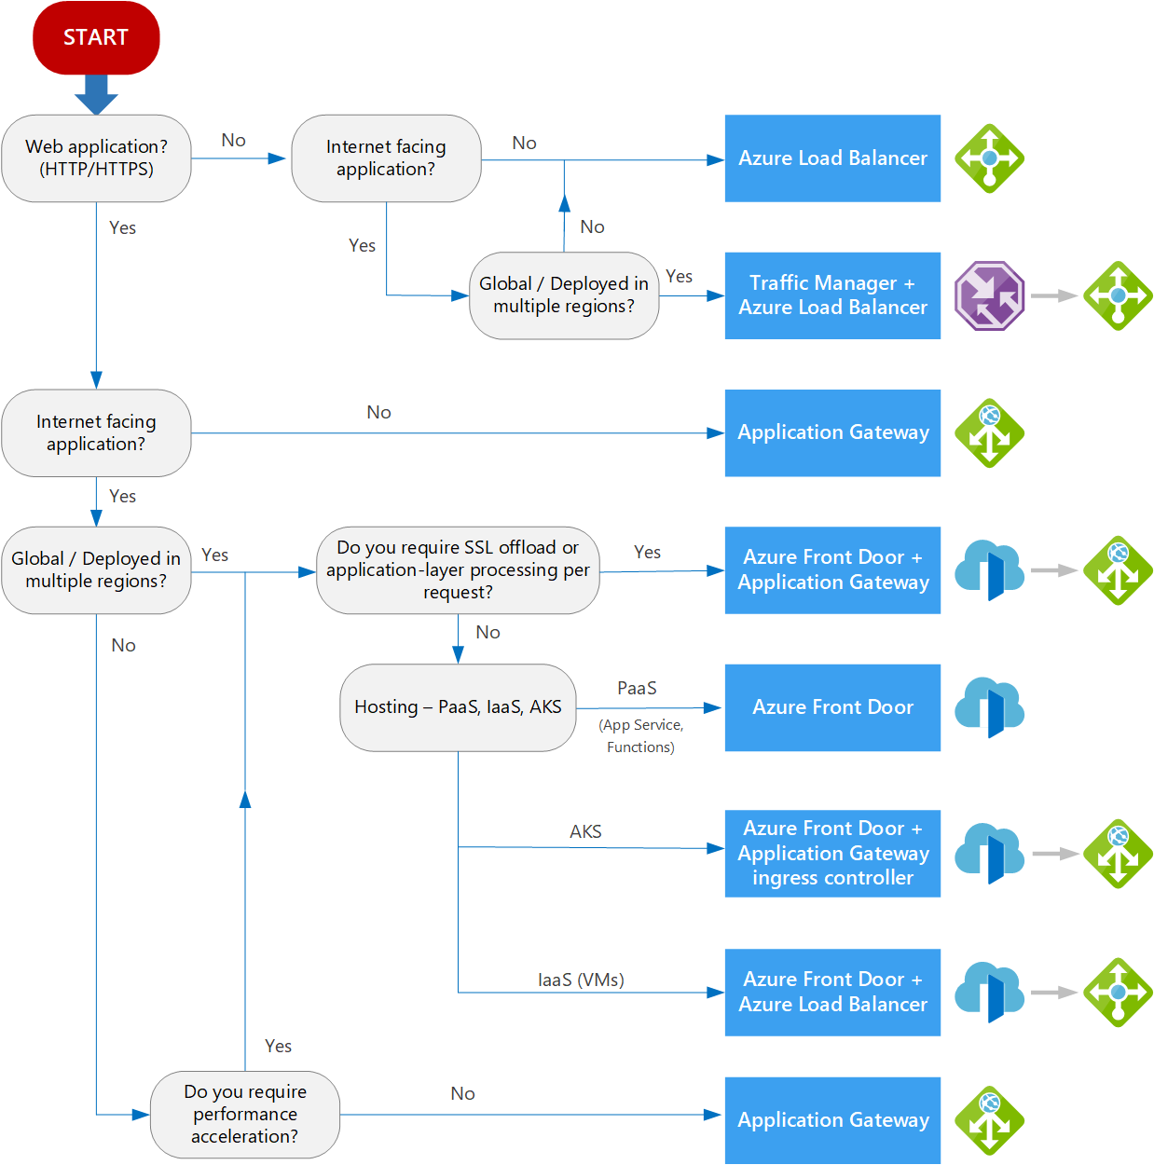
Design and implement Azure load balancer using the Azure portal
Azure Load Balancer operates at layer 4 of the Open Systems Interconnection (OSI) model. It's the single point of contact for clients. Azure Load Balancer distributes inbound flows that arrive at the load balancer's front end to backend pool instances. These flows are according to configured load-balancing rules and health probes. The backend pool instances can be Azure Virtual Machines or instances in a virtual machine scale set.
Choosing a load balancer type
Load balancers can be public (external) or internal (private).
A public load balancer can provide outbound connections for virtual machines (VMs) inside your virtual network. These connections are accomplished by translating their private IP addresses to public IP addresses. External load balancers are used to distribute client traffic from the internet across your VMs. That internet traffic might come from web browsers, module apps, or other sources.
An internal load balancer is used where private IPs are needed at the frontend only. Internal load balancers are used to load balance traffic from internal Azure resources to other Azure resources inside a virtual network. A load balancer frontend can also be accessed from an on-premises network in a hybrid scenario.
This diagram shows how public and internal load balancers can work together.
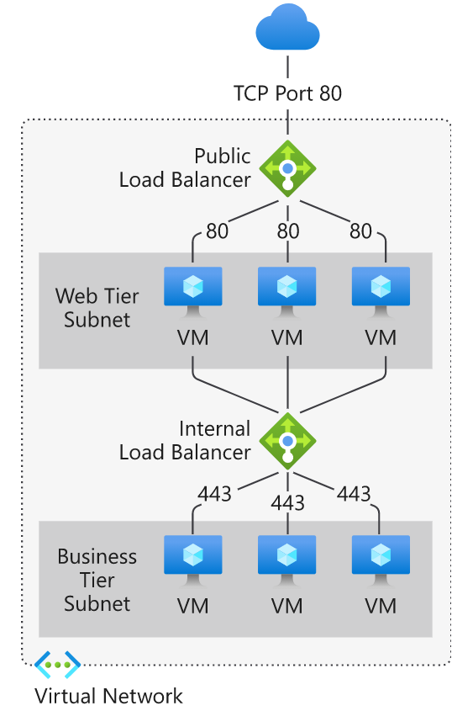
Azure load balancer and availability zones
Azure Load Balancer supports availability zones scenarios. A Load Balancer can either be zone redundant, zonal, or nonzonal.
Zone redundant
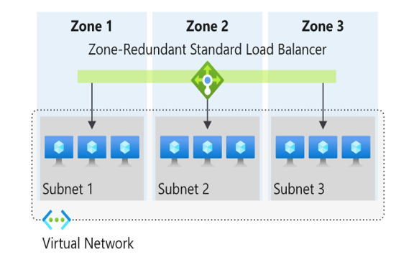
In a region with Availability Zones, a Standard Load Balancer can be zone-redundant. A single frontend IP address survives zone failure. The frontend IP can be used to reach all (nonimpacted) backend pool members no matter the zone. One or more availability zones can fail and the data path survives as long as one zone in the region remains healthy.
Nonzonal
Load Balancers can also use a "no-zone" frontend. In these scenarios, a public load balancer would use a public IP or public IP prefix, an internal load balancer would use a private IP. This option doesn't give a guarantee of redundancy.

Zonal
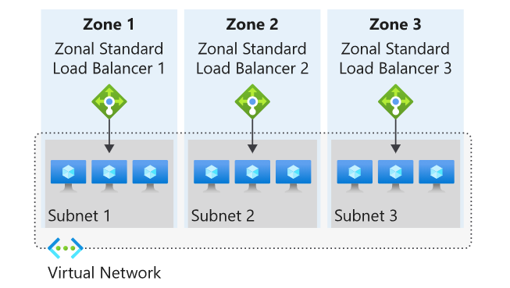
You can choose to have a frontend guaranteed to a single zone, which is known as a zonal. With this scenario, a single zone in a region serves all inbound or outbound flow. Your frontend shares fate with the health of the zone. The data path is unaffected by failures in zones other than where it was guaranteed.
Selecting an Azure load balancer SKU
There are several load balancer SKUs: Basic, Standard, and Gateway.
Features | Standard Load Balancer | Basic Load Balancer
Backend pool size | Supports up to 1,000 instances. | Supports up to 300 instances.
Backend pool endpoints | Any virtual machines or virtual machine scale sets in a single virtual network. | Virtual machines in a single availability set or virtual machine scale set.
Health probes | TCP, HTTP, HTTPS | TCP, HTTP
Health probe down behavior | TCP connections stay alive on an instance probe down and on all probes down. | TCP connections stay alive on an instance probe down. All TCP connections end when all probes are down.
Availability Zones | Zone-redundant and zonal frontends for inbound and outbound traffic. | Not available.
Diagnostics | Azure Monitor multi-dimensional metrics. | Azure Monitor logs
Secure by default | Closed to inbound flows unless allowed by a network security group. Internal traffic from the virtual network to the internal load balancer is allowed. | Open by default. Network security group optional.
Multiple front ends | Inbound and outbound | Inbound only

Architecture diagram
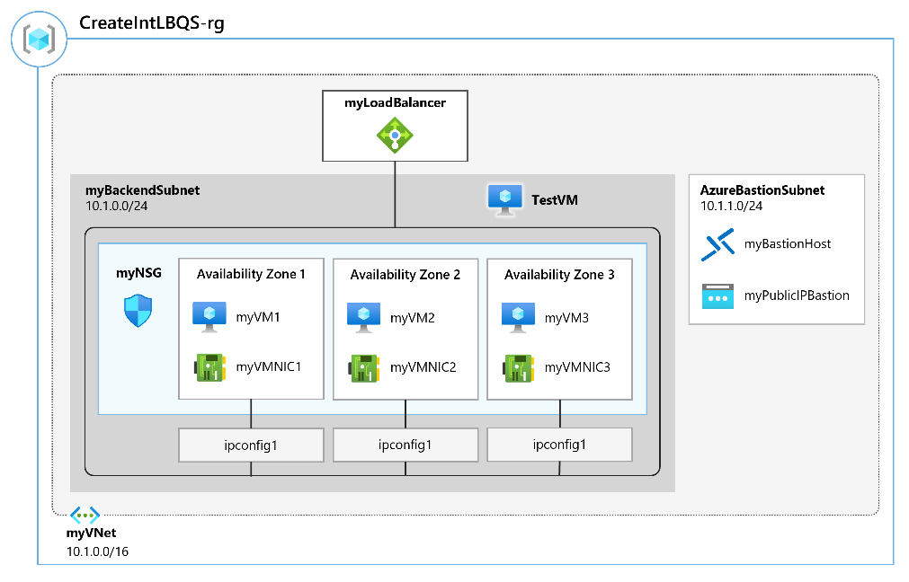
Objectives
- Task 1: Create the virtual network
- Task 2: Create backend servers
  - Use a template to create the virtual machines. You can review the lab template.
  - Use Azure PowerShell to deploy the template.
- Task 3: Create the load balancer
- Task 4: Create load balancer resources
- Task 5: Test the load balancer
Explore Azure Traffic Manager
Azure Traffic Manager is a DNS-based traffic load balancer. This service allows you to distribute traffic to your public facing applications across the global Azure regions. Traffic Manager also provides your public endpoints with high availability and quick responsiveness. The most important point to understand is that Traffic Manager works at the DNS level which is at the Application layer (Layer-7).
Feature | Description
Increase application availability | Traffic Manager delivers high availability for your critical applications by monitoring your endpoints and providing automatic failover when an endpoint goes down.
Improve application performance | Azure allows you to run cloud services and websites in datacenters located around the world. Traffic Manager can improve the responsiveness of your website by directing traffic to the endpoint with the lowest latency.
Service maintenance without downtime | You can plan maintenance on your applications without downtime. Traffic Manager can direct traffic to alternative endpoints while the maintenance is in progress.
Combine hybrid applications | Traffic Manager supports external, non-Azure endpoints enabling it to be used with hybrid cloud and on-premises deployments, including the burst-to-cloud, migrate-to-cloud, and failover-to-cloud scenarios.
Distribute traffic for complex deployments | Using nested Traffic Manager profiles, multiple traffic-routing methods are combined to create sophisticated and flexible rules to scale to the needs of larger, more complex deployments.

Traffic routing methods
Azure Traffic Manager supports different traffic-routing methods to determine how to route network traffic to the various service endpoints. You select the method that best fits your requirements.
Priority routing method
Use the priority routing method for a primary service endpoint for all traffic. You can provide multiple backup endpoints in case the primary or one of the backup endpoints is unavailable.
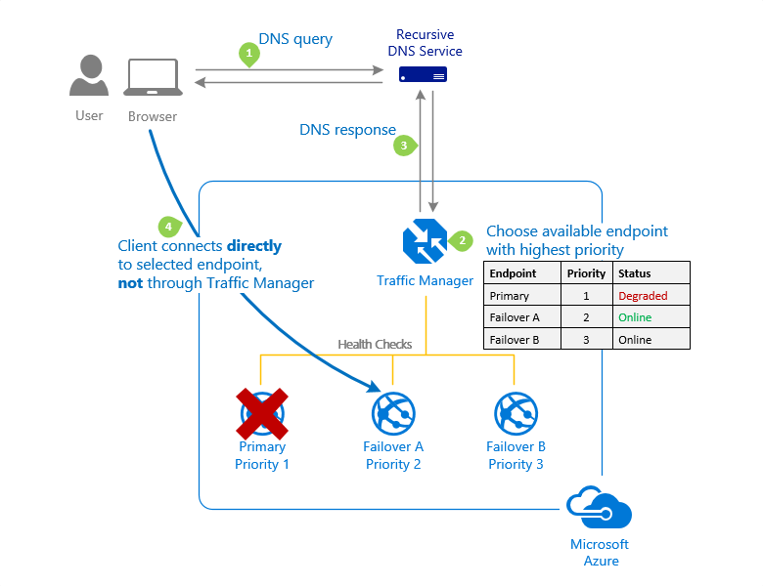
Weighted routing method
Use the Weighted routing method when you want to distribute traffic across a set of endpoints based on their importance. Set the weight the same to distribute evenly across all endpoints.
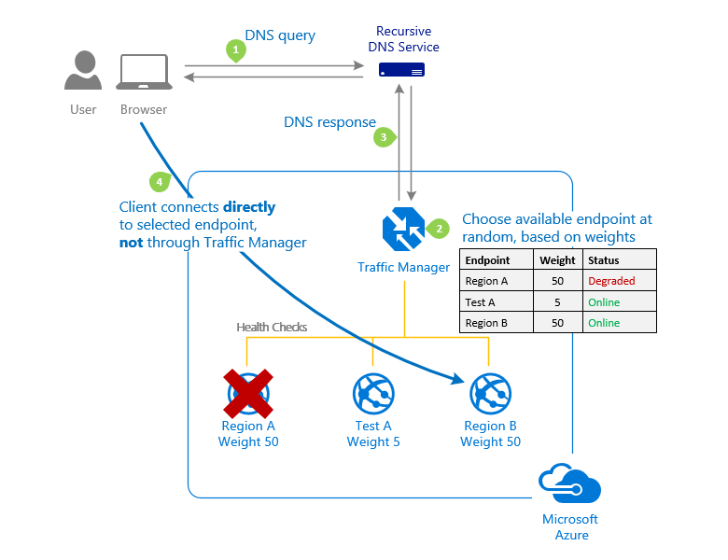
Performance routing method
Use the Performance routing method when endpoints are in different geographic locations. Users should use the "closest" endpoint for the lowest network latency.
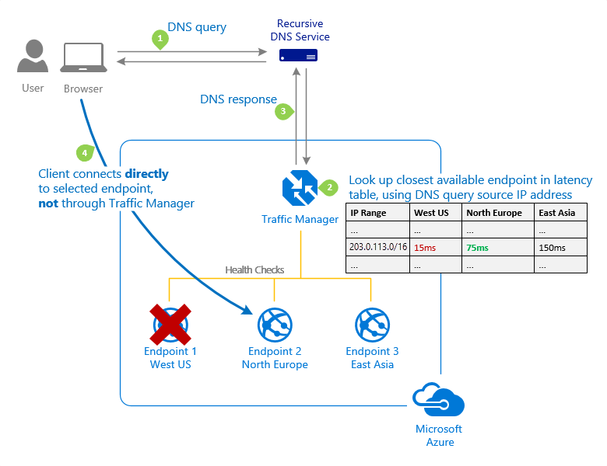
Geographic routing method
Use the Geographic routing method to direct users to specific endpoints based on where their DNS queries originate from geographically. Good choice for regional compliance requirements.
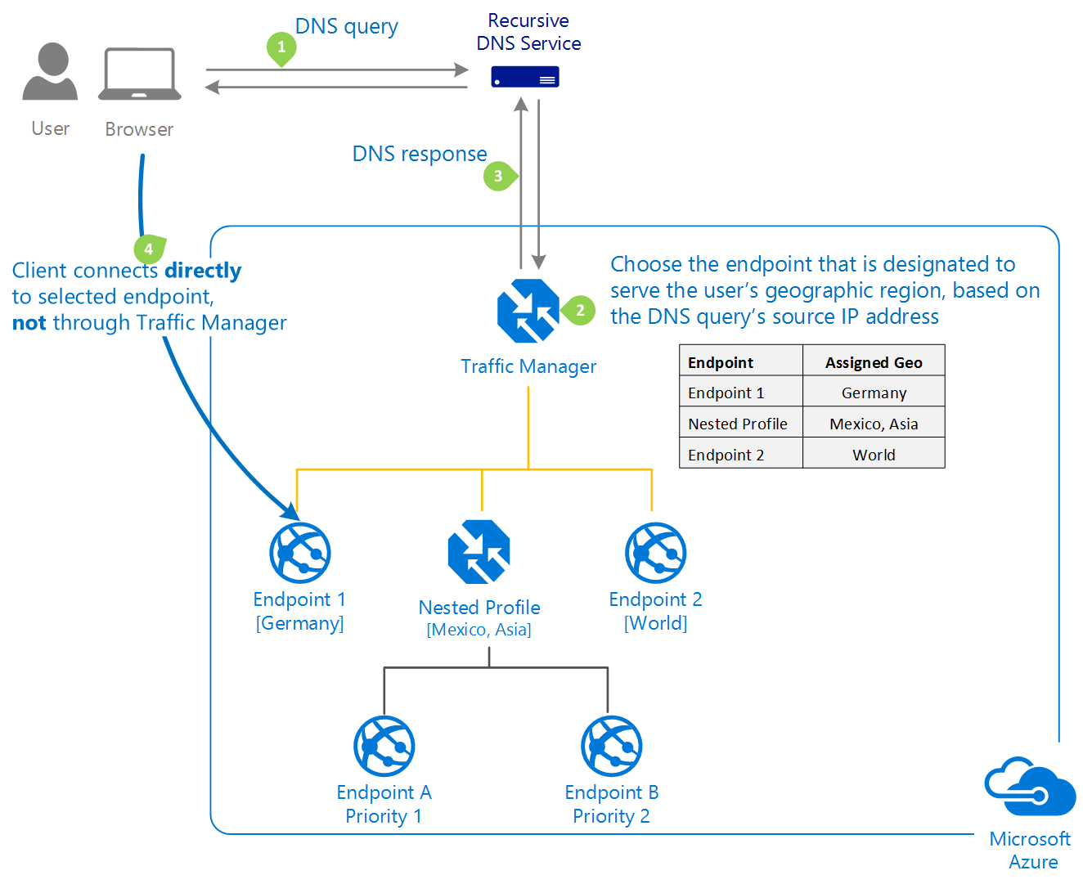

Load balance HTTP(S) traffic in Azure
https://learn.microsoft.com/en-us/training/modules/load-balancing-https-traffic-azure/
Azure Application Gateway and Azure Front Door are powerful tools provided by Microsoft Azure to manage web traffic, ensure high availability, and secure web applications.
The Azure Application Gateway processes network traffic to web apps hosted on a pool of web servers. This type of routing is known as application layer (OSI layer 7) load balancing.
- Support for the HTTP, HTTPS, HTTP/2, and WebSocket protocols.
- A web application firewall (WAF) to protect against web application vulnerabilities.
- End-to-end request encryption.
- Autoscaling to dynamically adjust capacity as your web traffic load change.
- Connection draining allowing graceful removal of backend pool members during planned service updates.
- Session stickiness to ensure client requests in the same session are routed to the same backend server.
- Path and URL based routing.
Let's review the Azure Application Gateway components.
- Front-end IP address. Client requests are received through a front-end IP address. You can configure the Application Gateway to have a public IP address, a private IP address, or both.
- Listeners. A listener is a logical entity that checks for incoming connection requests. A listener accepts a request if the protocol, port, hostname, and IP address match the listener's configuration. You must have at least one listener.
- Request routing rules. A request routing rule is a key component of an application gateway because it determines how to route traffic on the listener. The rule binds the listener, the backend server pool, and the backend HTTP settings. When a listener accepts a request, the request routing rule forwards the request to the backend or redirects it elsewhere. If the request is forwarded to the backend, the request routing rule defines which backend server pool to forward it to.
- Backend pools. A backend pool is a collection of web servers. Backend targets can include: a fixed set of virtual machines, a virtual machine scale-set, an app hosted by Azure App Services, or a collection of on-premises servers. The backend pool receives and processes requests.
- Health probes. Health probes determine which servers are available for load-balancing in a backend pool. Servers are automatically added and removed from the backend pool based on their availability.
Configure Azure Application Gateway

Path-based routing
Path-based routing sends requests with different URL paths to different pools of back-end servers. For example, you could direct video requests to a back-end pool optimized to handle video streaming. You could also direct image requests to a pool of servers that handles image retrieval.
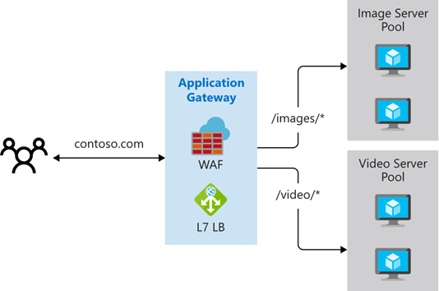
Multiple site routings
Multiple site routing configures more than one web application on the same Application Gateway instance. In a multiple site configuration, you register multiple DNS names (CNAMEs) for the IP address of the application gateway, specifying the name of each site. Application Gateway uses separate listeners to wait for requests for each site. Each listener passes the request to a different rule, which can route the requests to servers in a different back-end pool. For example, you could direct all requests for http://contoso.com to a specific backend pool.
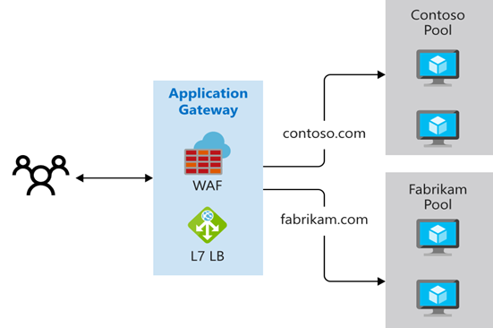
Other routing capabilities
Along with path-based routing and multiple site hosting, there are a few other capabilities when routing with Application Gateway.
- Redirection. Redirection can be used to another site, or from HTTP to HTTPS. For example, redirecting HTTP requests to a secure HTTPS shopping site.
- Rewrite HTTP headers. HTTP headers allow the client and server to pass additional information with the request or the response.
- Custom error pages. Application Gateway allows you to create custom error pages instead of displaying default error pages. You can use your own branding and layout using a custom error page.
Architecture diagram
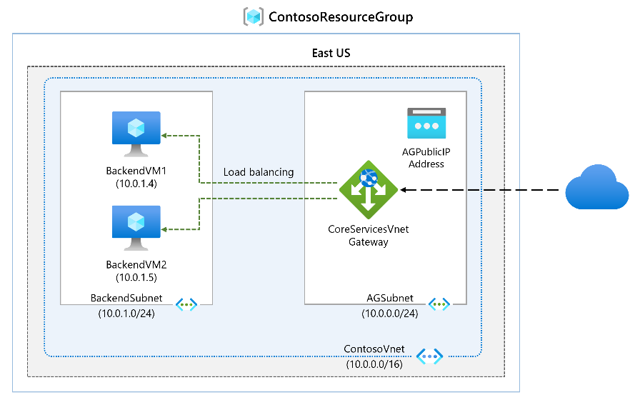
Objectives
- Task 1: Create an application gateway
- Task 2: Add backend targets
  - Use a template to create the virtual machines. You can review the lab template.
  - Use Azure PowerShell to deploy the template.
- Task 3: Add backend servers to backend pool
- Task 4: Test the application gateway
Design and configure Azure Front Door
Azure Front Door is Microsoft’s modern cloud Content Delivery Network (CDN) that provides fast, reliable, and secure access between your users and your applications. Azure Front Door delivers your content using the Microsoft’s global edge network with hundreds of global and local POPs distributed around the world close to both your enterprise and consumer end users.
Azure Front Door provides both content delivery and security features.
Azure Front Door Standard is content-delivery optimized.
- Provide for both static and dynamic content acceleration.
- Support global load balancing.
- Implement SSL offload.
- Implement domain and certificate management.
- Benefit from enhanced traffic analytics.
- Benefit from basic security capabilities.
Azure Front Door Premium is security optimized.
- Extensive security capabilities across Web Application Firewall.
- BOT protection.
- Private Link support.
- Integration with Microsoft Threat Intelligence and security analytics.
Azure Front Door usage cases
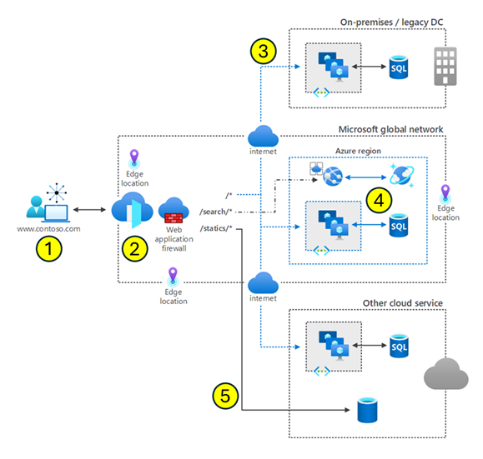
This diagram shows a user request processed by Azure Front Door.
- A user is requesting www.contoso.com. This request is routed from the client to Azure Front Door. Azure Front Door resides at the edge of the Microsoft Global Network. In Azure, an edge location is a data center that's geographically closer to end-users than traditional Azure regions. These locations are designed to cache content and deliver services with lower latency, improving the speed and responsiveness of applications for users worldwide.
- Azure Front Door determines where to direct the client request. The routing process includes the web application firewall, routing rules, rules engine, and caching configuration.
- A nonspecific request can be routed to any one of the three regions.
- A search request can be routed to a specific region optimized for search.
- A request can even be routed to a region with another cloud service.
Other things to know
- Routing algorithm. The Azure Front Door routing algorithm first matches based on HTTP protocol, then frontend host, then the Path.
  - HTTP Protocols (HTTP/HTTPS)
  - Hosts (for example, www.foo.com, *.bar.com)
  - Paths (for example, /, /users/, /file.gif)
- Response codes. Azure Front Door response codes help clients understand the purpose of the redirect. You can set the protocol used for redirection. The most common use case of the redirect feature is to set HTTP to HTTPS redirection.
- Health probes. Front Door periodically sends a synthetic HTTP/HTTPS request to each of your configured backends. Front Door then uses these responses from the probe to determine the "best" backend resources to route your client requests.
Lab scenario
In this lab, you set up an Azure Front Door configuration that pools two instances of a web application that runs in different Azure regions. This configuration directs traffic to the nearest site that runs the application. Azure Front Door continuously monitors the web application. You demonstrate automatic failover to the next available site when the nearest site is unavailable.
Architecture diagram
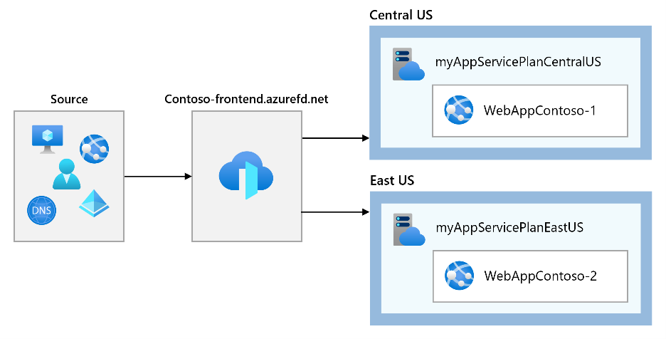
Objectives
- Task 1: Create two instances of a web app
- Task 2: Create a Front Door for your application
- Task 3: View Azure Front Door in action

Design and implement network security
https://learn.microsoft.com/en-us/training/modules/design-implement-network-security-monitoring/1-introduction
Network security is the process of protecting resources from unauthorized access or attack by applying controls to network traffic.
Your security requirements might include:
- Authentication and authorization (for your application)
- Intrusion detection and response
- URL filtering
- Application access control
- DDoS protection
Network Security
Network Security covers controls to secure and protect Azure networks. These controls include securing virtual networks, establishing private connections, preventing and mitigating external attacks, and securing DNS. A full description of the network security controls can be found at Security Control V3: Network Security on Microsoft Learn.
NS-1: Establish network segmentation boundaries
Security Principle. Ensure that your virtual network deployment aligns to your enterprise segmentation strategy. Any workload that incurs higher risk for the organization should be in isolated virtual networks.
NS-2: Secure cloud services with network controls
Security Principle. Secure cloud services by establishing a private access point for the resources. You should also disable or restrict access from public network when possible.
NS-3: Deploy firewall at the edge of enterprise network
Security Principle. Deploy a firewall to perform advanced filtering on network traffic to and from external networks. You can also use firewalls between internal segments to support a segmentation strategy. If necessary, use custom routes for your subnet to override the system route. This method forces the network traffic to go through a network appliance for security control purpose.
NS-4: Deploy intrusion detection/intrusion prevention systems (IDS/IPS)
Security Principle. Use network intrusion detection and intrusion prevention systems (IDS/IPS) to inspect the network and payload traffic to or from your workload. Ensure that IDS/IPS is always tuned to provide high-quality alerts to your solution.
NS-5: Deploy DDOS protection
Security Principle. Deploy distributed denial of service (DDoS) protection to protect your network and applications from attacks.
NS-6: Deploy web application firewall
Security Principle. Deploy a web application firewall (WAF) and configure the appropriate rules to protect your web applications and APIs from application-specific attacks.
NS-7: Simplify network security configuration
Security Principle. When managing a complex network environment, use tools to simplify, centralize, and enhance the network security management.
NS-8: Detect and disable insecure services and protocols
Security Principle. Detect and disable insecure services and protocols at the OS, application, or software package layer. Deploy compensating controls if disabling insecure services and protocols aren't possible.
NS-9: Connect on-premises or cloud network privately
Security Principle. Use private connections for secure communication between different networks, such as cloud service provider datacenters and on-premises infrastructure in a colocation environment.
NS-10: Ensure Domain Name System (DNS) security
Security Principle. Ensure that Domain Name System (DNS) security configuration protects against known risks.
Deploy Azure DDoS Protection by using the Azure portal
Distributed Denial of Service (DDoS)
DDoS attacks are some of the largest availability and security concerns facing customers that are moving their applications to the cloud. A DDoS attack tries to drain an APIs or application's resources, making that application unavailable to legitimate users. DDoS attacks can be targeted at any endpoint that is publicly reachable through the internet.
DDoS implementation
Azure DDoS Protection, combined with application design best practices, provide defense against DDoS attacks. Azure DDoS Protection provides the following service tiers:
- Network Protection. Provides mitigation capabilities over DDoS infrastructure Protection that are tuned specifically to Azure Virtual Network resources. Azure DDoS Protection is simple to enable, and requires no application changes. Policies are applied to public IP addresses associated to resources deployed in virtual networks. Real-time telemetry is available through Azure Monitor views during an attack, and for history. Rich attack mitigation analytics are available via diagnostic settings. Application layer protection can be added through the Azure Application Gateway Web Application Firewall (WAF). Protection is provided for IPv4 and IPv6 Azure public IP addresses.
- IP Protection. DDoS IP Protection is a pay-per-protected IP model. DDoS IP Protection contains the same core engineering features as DDoS Network Protection. However, there are value-added services like DDoS rapid response support, cost protection, and discounts on WAF.
DDoS Protection protects resources in a virtual network. Protection includes virtual machine public IP addresses, load balancers, and application gateways. When coupled with the Application Gateway WAF, DDoS Protection can provide full layer 3 to layer 7 mitigation capabilities.

Types of DDoS attacks
DDoS Protection can mitigate the following types of attacks.
- Volumetric attacks. These attacks flood the network layer with a substantial amount of seemingly legitimate traffic. They include UDP floods, amplification floods, and other spoofed-packet floods.
- Protocol attacks. These attacks render a target inaccessible, by exploiting a weakness in the layer 3 and layer 4 protocol stack. Attacks include SYN flood attacks, reflection attacks, and other protocol attacks.
- Resource (application) layer attacks. These attacks target web application packets, to disrupt the transmission of data between hosts. Attacks include HTTP protocol violations, SQL injection, cross-site scripting, and other layer 7 attacks.
Azure DDoS protection features
Some of Azure DDoS protection features include:
- Native platform integration. Natively integrated into Azure and configured through portal.
- Turnkey protection. Simplified configuration protecting all resources immediately.
- Always-on traffic monitoring. Your application traffic patterns are monitored 24 hours a day, 7 days a week, looking for indicators of DDoS attacks.
- Adaptive tuning. Profiling and adjusting to your service's traffic.
- Attack analytics. Get detailed reports in five-minute increments during an attack, and a complete summary after the attack ends.
- Attack metrics and alerts. Summarized metrics from each attack are accessible through Azure Monitor. Alerts can be configured at the start and stop of an attack, and over the attack's duration, using built-in attack metrics.
- Multi-layered protection. When deployed with a WAF, DDoS Protection protects both at the network layer and the application layer.
Always-on traffic monitoring
DDoS Protection monitors actual traffic utilization and constantly compares it against the thresholds defined in the DDoS Policy. When the traffic threshold is exceeded, DDoS mitigation is initiated automatically. When traffic returns below the thresholds, the mitigation is stopped.
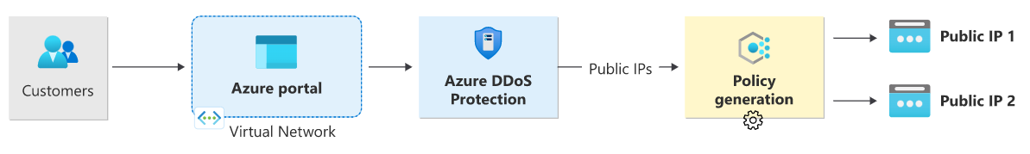
- Ensure packets conform to internet specifications and aren't malformed.
- Interact with the client to determine if the traffic is potentially a spoofed packet (e.g: SYN Auth or SYN Cookie or by dropping a packet for the source to retransmit it).
- Rate-limit packets if no other enforcement method can be performed.
Adaptive real-time tuning
The Azure DDoS Protection service helps protect customers and prevent impacts to other customers. For example, if a service is provisioned for a typical volume of legitimate incoming traffic that is smaller than the trigger rate of the infrastructure-wide DDoS Protection policy, a DDoS attack on that customer’s resources might go unnoticed. More generally, the complexity of recent attacks (for example, multi-vector DDoS) and the application-specific behaviors of tenants call for per-customer, tailored protection policies.
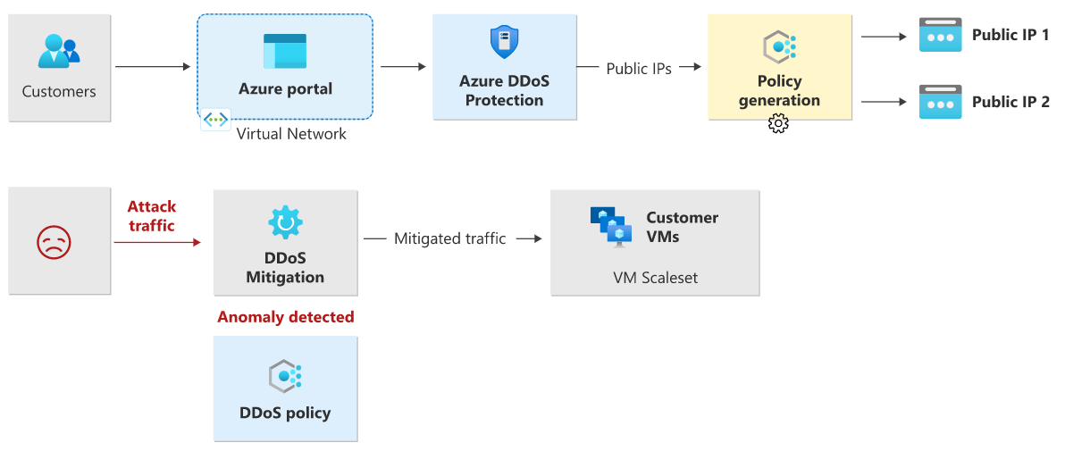
Attack metrics, alerts, and logs
DDoS Protection exposes rich telemetry via the Azure Monitor tool. You can configure alerts for any of the Azure Monitor metrics that DDoS Protection uses. You can integrate logging with Splunk (Azure Event Hubs), Azure Monitor logs, and Azure Storage for advanced analysis via the Azure Monitor Diagnostics interface.
In the Azure portal, select Monitor > Metrics. In the Metrics pane, select the resource group, select a resource type of Public IP Address, and select your Azure public IP address. DDoS metrics are visible in the Available metrics pane.
Multi-layered protection
Specific to resource attacks at the application layer, you should configure a WAF to help secure web applications. A WAF inspects inbound web traffic to block SQL injections, cross-site scripting, DDoS, and other Layer 7 attacks. Azure provides WAF as a feature of Application Gateway for centralized protection of your web applications from common exploits and vulnerabilities. There are other WAF offerings available from Azure partners in the Azure Marketplace.
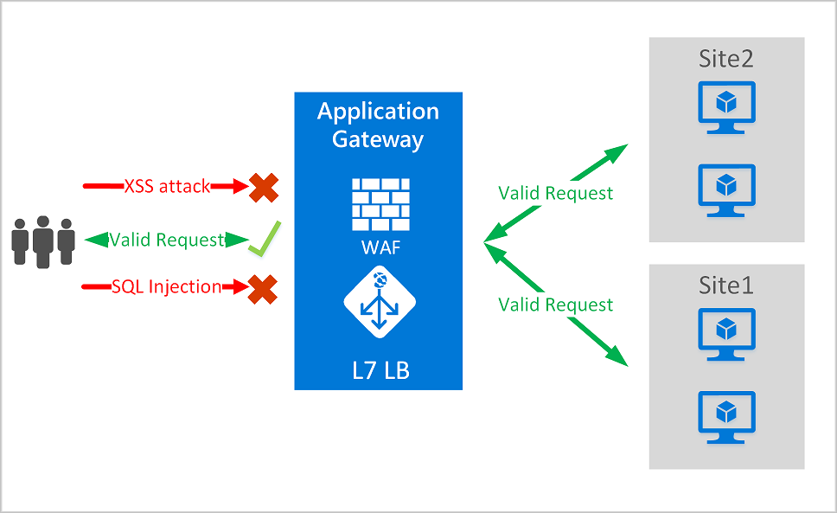
Deploying a DDoS protection plan
The key stages of deploying a DDoS Protection plan are as follows:
- Create a resource group
- Create a DDoS Protection Plan
- Enable DDoS protection on a new or existing virtual network or IP address
- Configure DDoS telemetry
- Configure DDoS diagnostic logs
- Configure DDoS alerts
- Run a test DDoS attack and monitor the results.
Architecture diagram
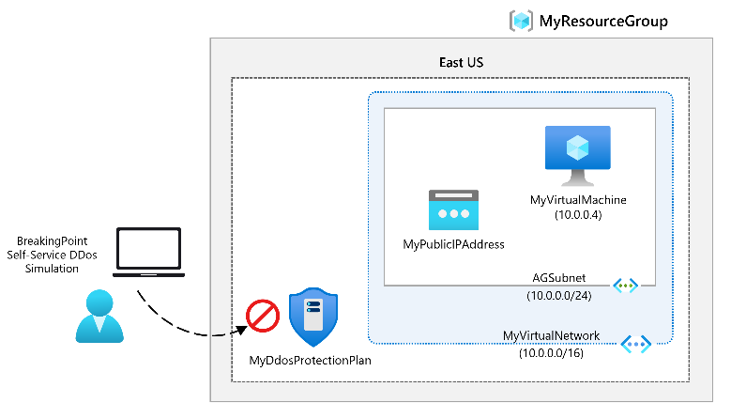
Objectives
- Task 1: Create a DDoS Protection plan.
- Task 2: Enable DDoS Protection on a new virtual network.
- Task 3: Configure DDoS telemetry.
- Task 4: Configure DDoS diagnostic logs.
- Task 5: Configure DDoS alerts.
- Task 6: Monitor a DDoS test attack.
Deploy Network Security Groups by using the Azure portal
A Network Security Group (NSG) in Azure allows you to filter network traffic to and from Azure resources in an Azure virtual network. A network security group contains security rules that allow or deny inbound network traffic to, or outbound network traffic from, several types of Azure resources. For each rule, you can specify source and destination, port, and protocol.
NSG security rules
A network security group contains zero, or as many rules as desired, within Azure subscription limits. Each rule has these properties.
- Name. Must be a unique name within the network security group.
- Priority. Can be any number between 100 and 4096. Rules are processed in priority order, with lower numbers processed before higher numbers, because lower numbers have higher priority. Once traffic matches a rule, processing stops. A
- Source or destination. Can be set to Any, or an individual IP address, or classless inter-domain routing (CIDR) block (10.0.0.0/24, for example), service tag, or application security group.
- Protocol. Can be TCP, UDP, ICMP, ESP, AH, or Any.
- Direction. Can be configured to apply to inbound, or outbound traffic.
- Port range. Can be specified either as an individual port or range of ports. For example, you could specify 80 or 10000-10005. Specifying ranges enables you to create fewer security rules.
- Action. Can be configured to allow or deny.
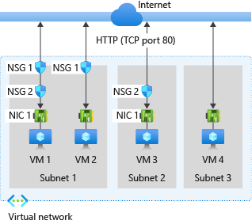
For inbound traffic Azure processes the rules in a network security group associated to a subnet first, if there's one, and then the rules in a network security group associated to the network interface, if there's one.
- VM1: Subnet1 is associated with NSG1, so the security rules are processed, and VM1 is in Subnet1. Unless you created a rule that allows port 80 inbound, the DenyAllInbound default security rule denies the traffic, and never evaluated by NSG2, since NSG2 is associated to the network interface. If NSG1 has a security rule that allows port 80, NSG2 then processes the traffic. To allow port 80 to the virtual machine, both NSG1 and NSG2 must have a rule that allows port 80 from the internet.
- VM2: The rules in NSG1 are processed because VM2 is also in Subnet1. Since VM2 doesn't have a network security group associated to its network interface, it receives all traffic allowed through NSG1 or is denied all traffic denied by NSG1. Traffic is either allowed or denied to all resources in the same subnet when a network security group is associated to a subnet.
- VM3: Since there's no network security group associated to Subnet2, traffic is allowed into the subnet and processed by NSG2, because NSG2 is associated to the network interface attached to VM3.
- VM4: Traffic is allowed to VM4, because a network security group isn't associated to Subnet3, or the network interface in the virtual machine. All network traffic is allowed through a subnet and network interface if they don't have a network security group associated to them.
For outbound traffic, Azure processes the rules in a network security group associated to a network interface first, if there's one, and then the rules in a network security group associated to the subnet, if there's one.
- VM1: The security rules in NSG2 are processed. Unless you create a security rule that denies port 80 outbound to the internet, the AllowInternetOutbound default security rule allows the traffic in both NSG1 and NSG2. If NSG2 has a security rule that denies port 80, the traffic is denied, and NSG1 never evaluates it. To deny port 80 from the virtual machine, either, or both of the network security groups must have a rule that denies port 80 to the internet.
- VM2: All traffic is sent through the network interface to the subnet, since the network interface attached to VM2 doesn't have a network security group associated to it. The rules in NSG1 are processed.
- VM3: If NSG2 has a security rule that denies port 80, the traffic is denied. If NSG2 has a security rule that allows port 80, then port 80 is allowed outbound to the internet, since a network security group isn't associated to Subnet2.
- VM4: All network traffic is allowed from VM4, because a network security group isn't associated to the network interface attached to the virtual machine, or to Subnet3.
Application Security Groups
An Application Security Group (ASG) enables you to configure network security as a natural extension of an application's structure, allowing you to group virtual machines and define network security policies based on those groups. You can reuse your security policy at scale without manual maintenance of explicit IP addresses.
Filter network traffic with an NSG using the Azure portal
You can use a network security group to filter network traffic inbound and outbound from a virtual network subnet. Network security groups contain security rules that filter network traffic by IP address, port, and protocol. Security rules are applied to resources deployed in a subnet.
The key stages to filter network traffic with an NSG are:
- Create a resource group.
- Create a virtual network.
- Create application security groups.
- Create a network security group.
- Associate a network security group with a subnet.
- Create security rules.
- Associate NICs to an ASG.
- Test traffic filters.

Design and implement Azure Firewall
Azure Firewall is a managed, cloud-based network security service that protects your Azure Virtual Network resources. It's a fully stateful firewall as a service with built-in high availability and unrestricted cloud scalability.
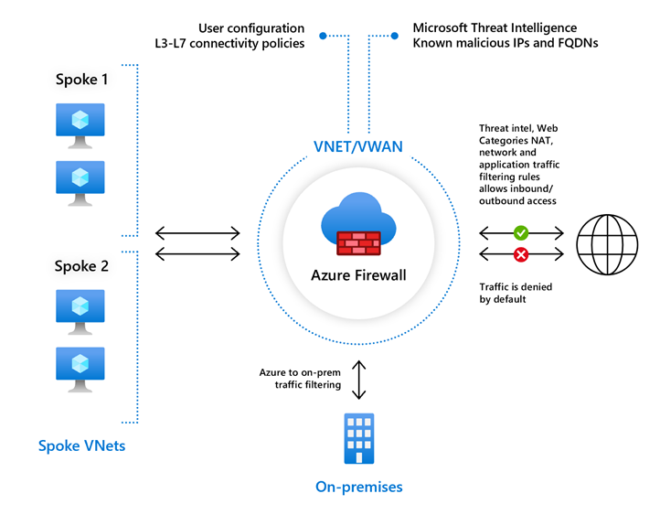
Rule processing in Azure Firewall
In the Azure Firewall, you can configure NAT rules, network rules, and applications rules. An Azure Firewall denies all traffic by default, until rules are manually configured to allow traffic.
Azure Firewall features
Azure Firewall includes these features.
- Built-in high availability. High availability is built in, so no extra load balancers are required and there's nothing you need to configure.
- Unrestricted cloud scalability. Azure Firewall can scale out as much as you need to accommodate changing network traffic flows, so you don't need to budget for your peak traffic.
- Application FQDN filtering rules. You can limit outbound HTTP/S traffic or Azure SQL traffic to a specified list of fully qualified domain names (FQDN) including wild cards. This feature doesn't require TLS termination.
- Network traffic filtering rules. You can centrally create allow or deny network filtering rules by source and destination IP address, port, and protocol. Azure Firewall is fully stateful, so it can distinguish legitimate packets for different types of connections. Rules are enforced and logged across multiple subscriptions and virtual networks.
- FQDN tags. These tags make it easy for you to allow well-known Azure service network traffic through your firewall. For example, say you want to allow Windows Update network traffic through your firewall. You create an application rule and include the Windows Update tag. Now network traffic from Windows Update can flow through your firewall.
- Service tags. A service tag represents a group of IP address prefixes to help minimize complexity for security rule creation. You can't create your own service tag, nor specify which IP addresses are included within a tag. Microsoft manages the address prefixes encompassed by the service tag, and automatically updates the service tag as addresses change.
- Threat intelligence. Threat intelligence-based filtering (IDPS) can be enabled for your firewall to alert and deny traffic from/to known malicious IP addresses and domains. The IP addresses and domains are sourced from the Microsoft Threat Intelligence feed.
- TLS inspection. The firewall can decrypt outbound traffic, processes the data, then encrypt the data and sends it to the destination.
- Outbound SNAT support. All outbound virtual network traffic IP addresses are translated to the Azure Firewall public IP (Source Network Address Translation (SNAT)). You can identify and allow traffic originating from your virtual network to remote Internet destinations.
- Inbound DNAT support. Inbound Internet network traffic to your firewall public IP address is translated (Destination Network Address Translation) and filtered to the private IP addresses on your virtual networks.
- Multiple public IP addresses. You can associate multiple public IP addresses (up to 250) with your firewall, to enable specific DNAT and SNAT scenarios.
- Azure Monitor logging. All events are integrated with Azure Monitor, allowing you to archive logs to a storage account, stream events to your Event Hubs, or send them to Azure Monitor logs.
- Forced tunneling. You can configure Azure Firewall to route all Internet-bound traffic to a designated next hop instead of going directly to the Internet. For example, you have an on-premises edge firewall or other network virtual appliance (NVA) to process Internet network traffic.
- Web categories. Web categories let administrators allow or deny user access to web site categories such as gambling websites, social media websites, and others. Web categories are included in Azure Firewall Standard, but it's more fine-tuned in Azure Firewall Premium Preview. As opposed to the Web categories capability in the Standard SKU that matches the category based on an FQDN, the Premium SKU matches the category according to the entire URL for both HTTP and HTTPS traffic.
- Certifications. Azure Firewall is Payment Card Industry (PCI), Service Organization Controls (SOC), International Organization for Standardization (ISO), and ICSA Labs compliant.
Rule processing in Azure Firewall
In the Azure Firewall, you can configure NAT rules, network rules, and applications rules. An Azure Firewall denies all traffic by default, until rules are manually configured to allow traffic.
Architecture diagram
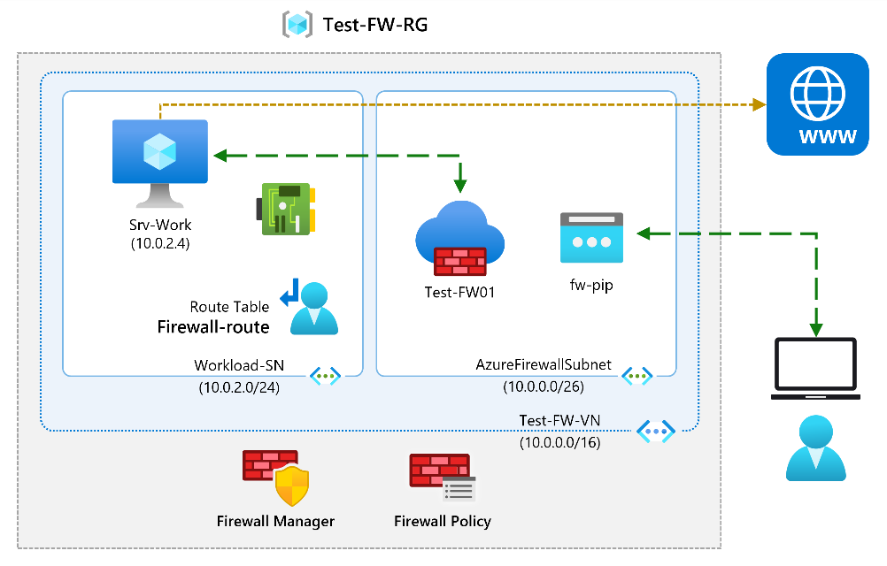
Objectives
- Task 1: Create a virtual network and subnets.
- Task 2: Create a virtual machine.
  - Use a template to create the virtual machines. You can review the lab template.
  - Use Azure PowerShell to deploy the template.
- Task 3: Deploy the firewall and firewall policy.
- Task 4: Create a default route.
- Task 5: Configure an application rule.
- Task 6: Configure a network rule.
- Task 7: Configure a Destination NAT (DNAT) rule.
- Task 8: Change the primary and secondary DNS address for the server's network interface.
- Task 9: Test the firewall.
Secure your networks with Azure Firewall Manager
If you manage multiple firewalls, it's often difficult to keep the firewall rules in sync.
Azure Firewall Manager helps solve these problems. Azure Firewall Manager provides centralized configuration and management across multiple Azure Firewall instances. Azure Firewall Manager lets you create one or more firewall policies and rapidly apply them to multiple firewalls.
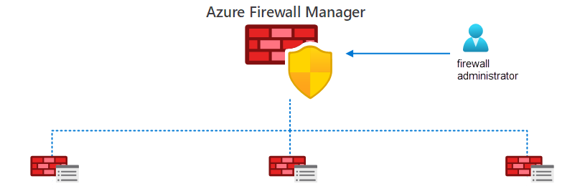
Firewall Manager can provide security management for secured virtual hubs and hub virtual networks.
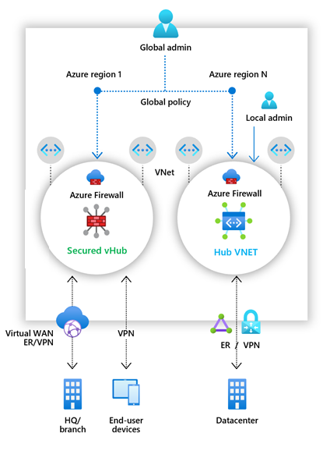
- Secured Virtual Hub. A Microsoft-managed resource that enables you to easily create hub and spoke architectures. When you associate policies, you're using a secured virtual hub. The underlying resource is a virtual WAN hub.
- Hub Virtual Network. A standard Azure virtual network that you create and manage. When you associate firewall policies with this type of hub, you're creating a hub virtual network. This architecture's underlying resource is a virtual network.
Azure Firewall Manager features
If your organization has multiple Azure Firewall instances, you benefit from centralizing these configurations. Firewall Manager enables you to:
- Span multiple Azure subscriptions.
- Span different Azure regions.
- Implement hub and spoke architectures to provide for traffic governance and protection.
Implement a Web Application Firewall
Web Application Firewall (WAF) provides centralized protection of your web applications from common exploits and vulnerabilities. SQL injections and cross-site scripting are among the most common attacks.
Preventing attacks in application code is challenging. Prevention can require rigorous maintenance, patching, and monitoring at multiple layers of the application. A centralized WAF helps make security management simpler. A WAF also gives application administrators better assurance of protection against threats and intrusions. A WAF solution can react to a security threat faster by centrally patching a known vulnerability, instead of securing each individual web application.
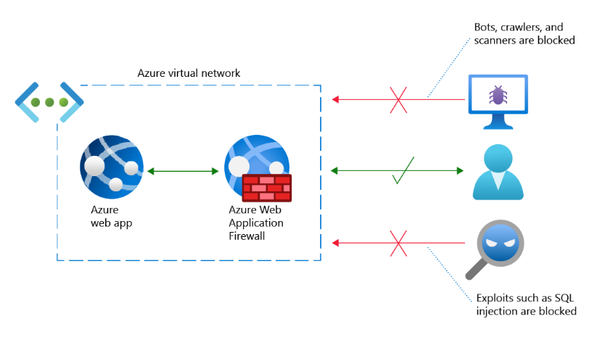
There are two WAF policy modes: Detection and Prevention. By default, the WAF policy is in Detection mode. In Detection mode, WAF doesn't block any requests. Instead, requests matching the WAF rules are logged. In Prevention mode, requests that match rules are blocked and logged.
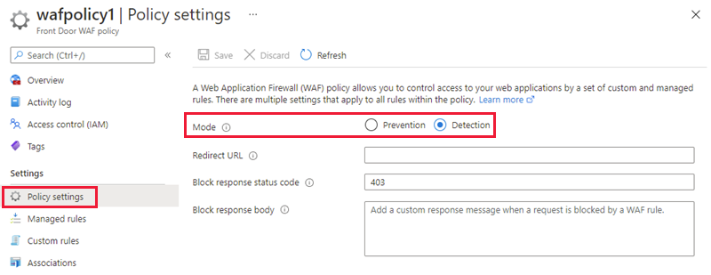
The Web Application Firewall works with the Application Gateway, Azure Front Door Service, and the Azure CDN Service.
Microsoft managed rule sets, rule groups, and rules
Azure Web Application Firewall thwarts known exploits by applying rules to an app's incoming HTTP/HTTPS requests. A rule is designed to recognize and prevent a particular threat.
- Cross-site scripting. A threat actor uses a web application to send malicious code to another user's web browser.
- Local file inclusion. An attacker exploits vulnerabilities in a server's handling of include statements, most often in PHP scripts.
- PHP injection attacks. The attacker inserts text specially configured to trick the server into running PHP commands.
- Remote command execution. The attacker tricks a server into running commands associated with the server's operating system.
- Session fixation. An attacker exploits a web app vulnerability that allows the attacker to obtain a valid session ID.
- SQL injection protection. In a web form field, the attacker inserts (or "injects") text specially configured to trick the server into running SQL commands.
- Protocol attackers. An attacker inserts specially configured text into an HTTP/HTTPS request header.
Design and implement private access to Azure Services
https://learn.microsoft.com/en-us/training/modules/design-implement-private-access-to-azure-services/1-introduction
Azure provides a range of services and features to enhance the security and privacy of your network connections. These services include Virtual Network Service Endpoints, Azure Private Link, Private Endpoint, and Azure Private Link Service. These technologies allow for secure and direct connectivity to Azure services over the Azure backbone network, replacing public endpoints with private network interfaces, and providing granular access control.
Virtual Network (VNet) Service Endpoint provides secure and direct connectivity to Azure services over the Azure backbone network. Endpoints allow you to secure your critical Azure service resources to only your virtual networks. Service endpoints enable private IP addresses in the virtual network to reach the endpoint of an Azure service.
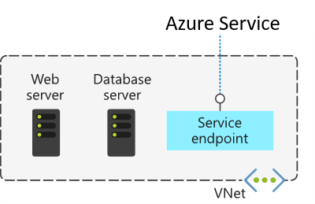
Azure Service Endpoints are available for many services, such as:
- Azure Storage
- Azure SQL Database
- Azure Cosmos DB
- Azure Key Vault
- Azure Service Bus
- Azure Data Lake
Virtual Network Service Endpoint policies Service endpoint policies enable you to filter virtual network traffic to specific Azure resources, over service endpoints. For example, endpoint policies could provide granular access control for virtual network traffic to Azure Storage when connecting over a Service Endpoint.
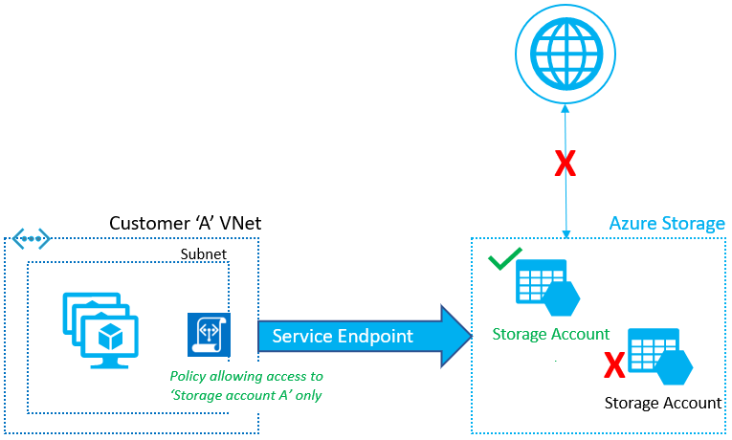
Define Private Link Service and private endpoint
even though both your virtual network and the Azure SQL database are located within the Azure cloud, the connection between them takes place over the internet.
The concern here's that your Azure SQL database is exposed to the internet through its public IP address. This exposure creates multiple security risks.
What is Azure Private Link?
Azure Private Link enables you to access Azure PaaS Services and Azure hosted customer-owned/partner services over a Private Endpoint in your virtual network. Private Link is designed to eliminate security risks by removing the public part of the connection.
There are three key points to consider with this new architecture.
- The Azure resource becomes, in a sense, a part of your virtual network.
- The connection to the resource now uses the Microsoft Azure backbone network instead of the public internet.
- You can configure the Azure resource to no longer expose its public IP address, which eliminates that potential security risk.
What is Azure Private Endpoint?
Azure private endpoint is the key technology behind private link. Private endpoint is a network interface that enables a private and secure connection between your virtual network and an Azure service. In other words, private endpoint is the network interface that replaces the resource's public endpoint
Private Link provides secure access to Azure services. Private Link achieves that security by replacing a resource's public endpoint with a private network interface. Private Endpoint uses the private IP address for services into the virtual network.
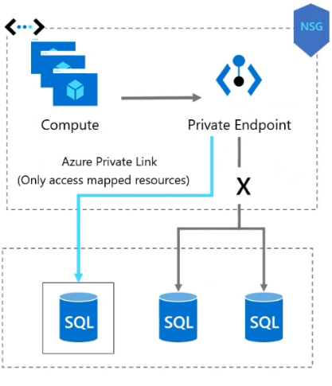
How is Azure Private Endpoint different from a service endpoint?
Private Endpoints grant network access to specific resources behind a given service providing granular segmentation. Traffic can reach the service resource from on premises without using public endpoints.
A service endpoint remains a publicly routable IP address. A private endpoint is a private IP in the address space of the virtual network where the private endpoint is configured.

Integrate private endpoint with Domain Name Service
What is Azure Private Link Service?
Azure Private Link service is the reference to your own service that is powered by Azure Private Link. Your service that is running behind Azure standard load balancer can be enabled for Private Link access so that consumers to your service can access it privately from their own VNets.
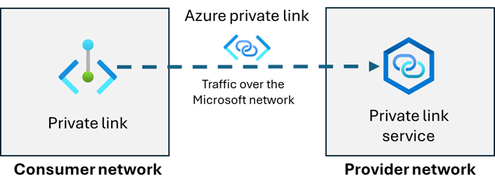
Private link and DNS integration for hub-spoke networks
The following diagram shows a typical high-level architecture for enterprise environments with central DNS resolution. The network architecture is hub-spoke network with Private Link resources and Azure Private DNS.
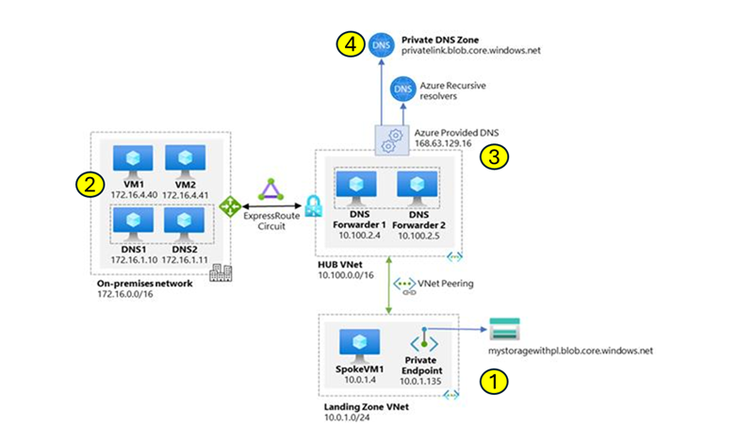
In the previous diagram, it's important to highlight:
- All Azure virtual networks use the DNS private resolver that is hosted in the hub virtual network.
- On-premises DNS servers have conditional forwarders configured for each private endpoint public DNS zone, pointing to the DNS private resolver hosted in the hub virtual network.
- The DNS private resolver hosted in the hub virtual network uses the Azure-provided DNS (168.63.129.16) as a forwarder. IP address 168.63.129.16 is a virtual public IP address that facilitates a communication channel to Azure platform resources.
- The hub virtual network must be linked to the Private DNS zone names for Azure services, such as privatelink.blob.core.windows.net, as shown in the diagram.

Exercise: Restrict network access to PaaS resources with virtual network service endpoints using the Azure portal
Service endpoints provide direct connection from your virtual network to supported Azure services, letting you use your virtual network's private address space to access the Azure services. Traffic destined to Azure resources through service endpoints always stays on the Microsoft Azure backbone network.
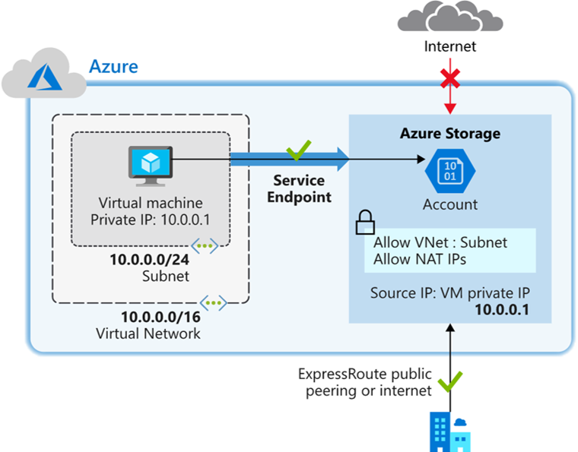
Objectives
- Task 1: Create a virtual network.
- Task 2: Enable a service endpoint.
- Task 3: Restrict network access for a subnet.
- Task 4: Add other outbound rules.
- Task 5: Allow access for RDP connections.
- Task 6: Restrict network access to a resource.
- Task 7: Create a file share in the storage account.
- Task 8: Restrict network access to a subnet.
- Task 9: Create virtual machines.
  - Use a template to create the virtual machines. You can review the lab template.
  - Use Azure PowerShell to deploy the template.
- Task 10: Confirm access to storage account.

Exercise: Create an Azure private endpoint using Azure PowerShell
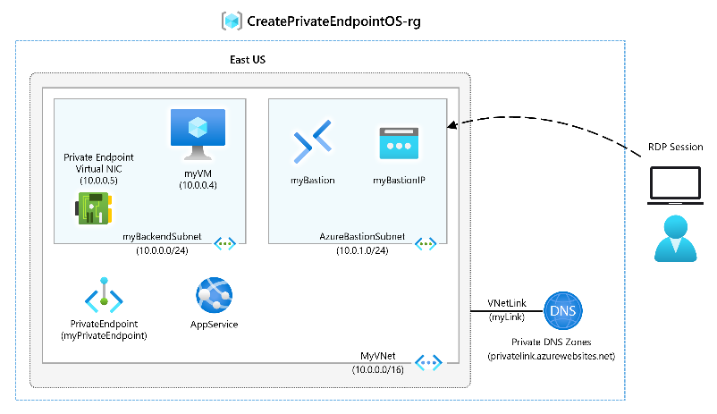
Objectives
- Task 1: Create a resource group and deploy the prerequisite web app.
  - Use a template to create the virtual machines. You can review the lab template.
  - Use Azure PowerShell to deploy the template.
- Task 2: Create a virtual network and bastion host.
- Task 3: Create a test virtual machine.
- Task 4: Create a private endpoint.
- Task 5: Configure the private DNS zone.
- Task 6: Test connectivity across the private endpoint.
The main takeaways from this module are:
- Service Endpoints limit the Azure service's access to the allowed virtual network and subnet. Service endpoints provide network-level security and isolation of the Azure service traffic.
- Service Endpoint policies allow you to filter egress virtual network trafficto the Service Endpoint. Policies
- Azure Private Link enables you to access Azure PaaS Services and Azure hosted customer-owned/partner services over a Private Endpoint in your virtual network. Private Link is designed to eliminate security risks by removing the public part of the connection.
- Azure private endpoint is the key technology behind private link. Private endpoint is a network interface that enables a private and secure connection between your virtual network and an Azure service.
- Azure Private Link service lets you offer Private Link connections to your custom Azure services. Consumers of your custom services can then access those services privately—that is, without using the internet—from their own Azure virtual networks.
- Azure DNS Private Resolver lets you query Azure DNS private zones from an on-premises environment and vice versa without deploying VM based DNS servers. When you use DNS Private Resolver, you don't need a DNS forwarder, and Azure DNS is able to resolve on-premises domain names.
Design and implement network monitoring
https://learn.microsoft.com/en-us/training/modules/design-implement-network-monitoring/1-introduction
What is Azure Monitor?
Azure Monitor is a comprehensive monitoring solution for collecting, analyzing, and responding to monitoring data from your cloud and on-premises environments. You can use Azure Monitor to maximize the availability and performance of your applications and services.
Here are a few usage cases for Azure Monitor.
- Use Application Insights to detect and diagnose issues across applications.
- Correlate infrastructure issues with VM insights and Container insights.
- Use Log Analytics to explore troubleshooting and diagnostics your monitoring data.
- Support operations at scale with smart alerts and automated actions.
- Create visualizations with Azure dashboards and workbooks.
- Collect data from monitored resources using Azure Monitor Metrics.
Azure Monitor components
At the center of the diagram are the two fundamental types of data stores: metrics and logs, In the left pane are the monitoring sources that populate these data stores. In the right pane are the different actions that Azure Monitor performs with this collected data. Actions include analysis, alerting, and streaming to external systems.
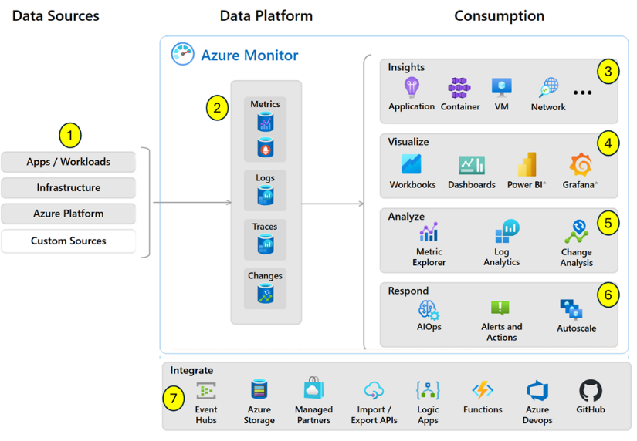
- Data sources are the types of resources being monitored. Data sources can include: app/workloads, infrastructure, Azure platform, and even custom sources.
- The data platform stores the collected data. Azure Monitor's core data platform has stores for metrics, logs, traces, and changes. Metrics are numerical values that describe an aspect of a system at a particular point in time. Logs are recorded system events.
- Insights are large, scalable, curated visualizations. Insights are available for applications, containers, networks, and virtual machines.
- Visualizations such as charts and tables are effective tools for summarizing monitoring data and presenting it to different audiences. Visualizations can include: dashboards, workbooks, Power BI, and Grafana. Grafana is an open platform that excels in operational dashboards.
- Analyze monitoring data includes metric explorer and log analytics.
- Respond proactively addresses critical events, before they become an issue. For example, the response could be a text or email to an administrator, or an automated process that attempts to correct an error condition.
- Integrate allows other systems or custom solutions to use your monitoring data. Integrate can include: Event Hubs, Azure storage, Logic Apps, Azure Functions, and APIs.
Architecture diagram
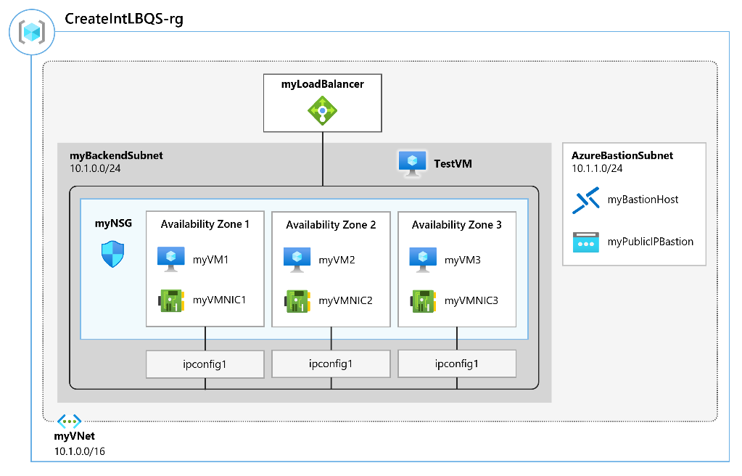
Objectives
- Task 1: Create the virtual network.
- Task 2: Create the load balancer.
- Task 3: Create a backend pool.
- Task 4: Create a health probe.
- Task 5: Create a load balancer rule.
- Task 6: Create backend servers.
  - Use a template to create the virtual machines. You can review the lab template.
  - Use Azure PowerShell to deploy the template.
- Task 7: Add VMs to the backend pool.
- Task 8: Install IIS on the VMs.
- Task 9: Test the load balancer.
- Task 10: Create a Log Analytics Workspace.
- Task 11: Use Functional Dependency View.
- Task 12: View detailed metrics.
- Task 13: View resource health.
- Task 14: Configure diagnostic settings.
- Task 15: Clean up resources.
Azure Network Watcher
Azure Network Watcher is a regional service that enables you to monitor and diagnose network conditions. Network diagnostic and visualization tools help you understand, diagnose, and gain insights to your network in Azure. Network Watcher is designed to monitor and repair the network health of IaaS products which includes virtual machines, virtual networks, Application Gateways, and Load Balancers.
Azure Network Watcher tools
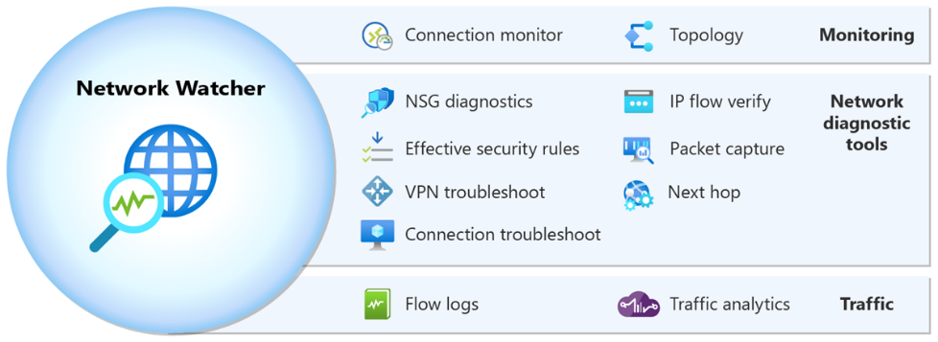
Monitoring tools
- Network Topology generates a visualization of the entire network for understanding network configuration.
- Connection monitor provides end-to-end connection monitoring for Azure and hybrid endpoints.
Diagnostic tools
- IP Flow Verify helps you to detect traffic filtering issues at a virtual machine level. It checks if a packet is allowed or denied to or from an IP address (IPv4 or IPv6 address). It also tells you which security rule allowed or denied the traffic.
- Next Hop helps you detect routing issues. It checks if traffic is routed correctly to the intended destination.
- Effective security rules shows you all security rules applied to the network interface, the subnet the network interface is in, and the aggregate of both.
- Connection troubleshoot tests connections between resources. For example, a virtual machine, a virtual machine scale set, or an application gateway.
- Packet Capture lets you remotely create packet capture sessions to record all network traffic to and from a virtual machine (VM) or a virtual machine scale set.
- VPN troubleshoot enables you to troubleshoot virtual network gateways and their connections.
Traffic tools
- Flow logs allows you to log information about your Azure IP traffic and stores the data in Azure storage. You can log IP traffic flowing through a network security group or Azure virtual network.
- Traffic analytics provides rich visualizations of flow logs data.
The main takeaways from this module are:
- Azure Monitor is a comprehensive monitoring solution for collecting, analyzing, and responding to monitoring data from your cloud and on-premises environments.
- You can use Azure Monitor to maximize the availability and performance of your applications and services.
- Azure Monitor has three parts: data sources, data platform, and consumption.
- Network Watcher is a regional service that enables you to monitor and diagnose network conditions.
- Network Watcher includes monitoring, diagnostic, and traffic analysis tools.

